D-311 Unit 7 Maps

Summary:
EXAMPLE Summary: This unit will focus on how to read and plot points on various maps.

Course Objectives:
By the end of this course students will be able to:
- Convert and plot locations using latitude / longitude and grid maps.
- Determine and plot locations using section, township, and range.
- Plot and give directions off Very High Frequency Ranges (VORs).
- Direct resources to plotted locations.

Course at a Glance:
Unit | Topic | Approx. Time
Unit #: Unit Name | This unit allows participants to learn about their peers in the class and become familiar with course goals and objectives. | # Minutes
Unit #: Unit Name | This module provides a brief review of … | # Minutes
Unit #: Unit Name | Example Topic | # Minutes
Unit #: Unit Name | Example Topic | # Minutes
Unit #: Unit Name | Example Topic | # Minutes
Unit #: Unit Name | Example Topic | # Minutes
Total Time |  | Total # Minutes

Preparation:

Course Materials:
- Burns Interagency Fire Zone Map
- Gazetteers
- Power Point presentation

Classroom:
- Ability to display images and video on large screen.
- White board or easel and maps access for group breakout.

Slide 1
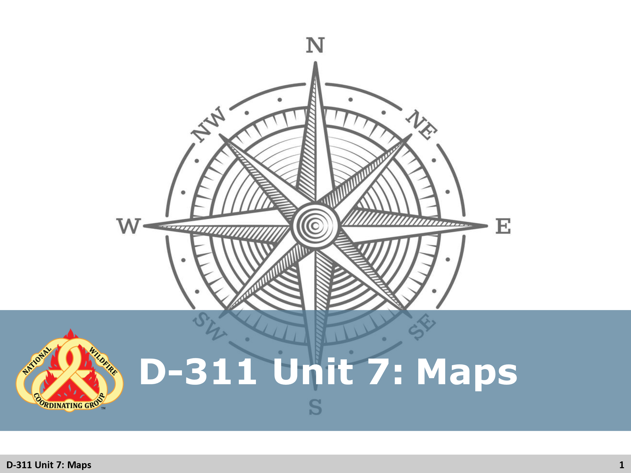

Slide 2
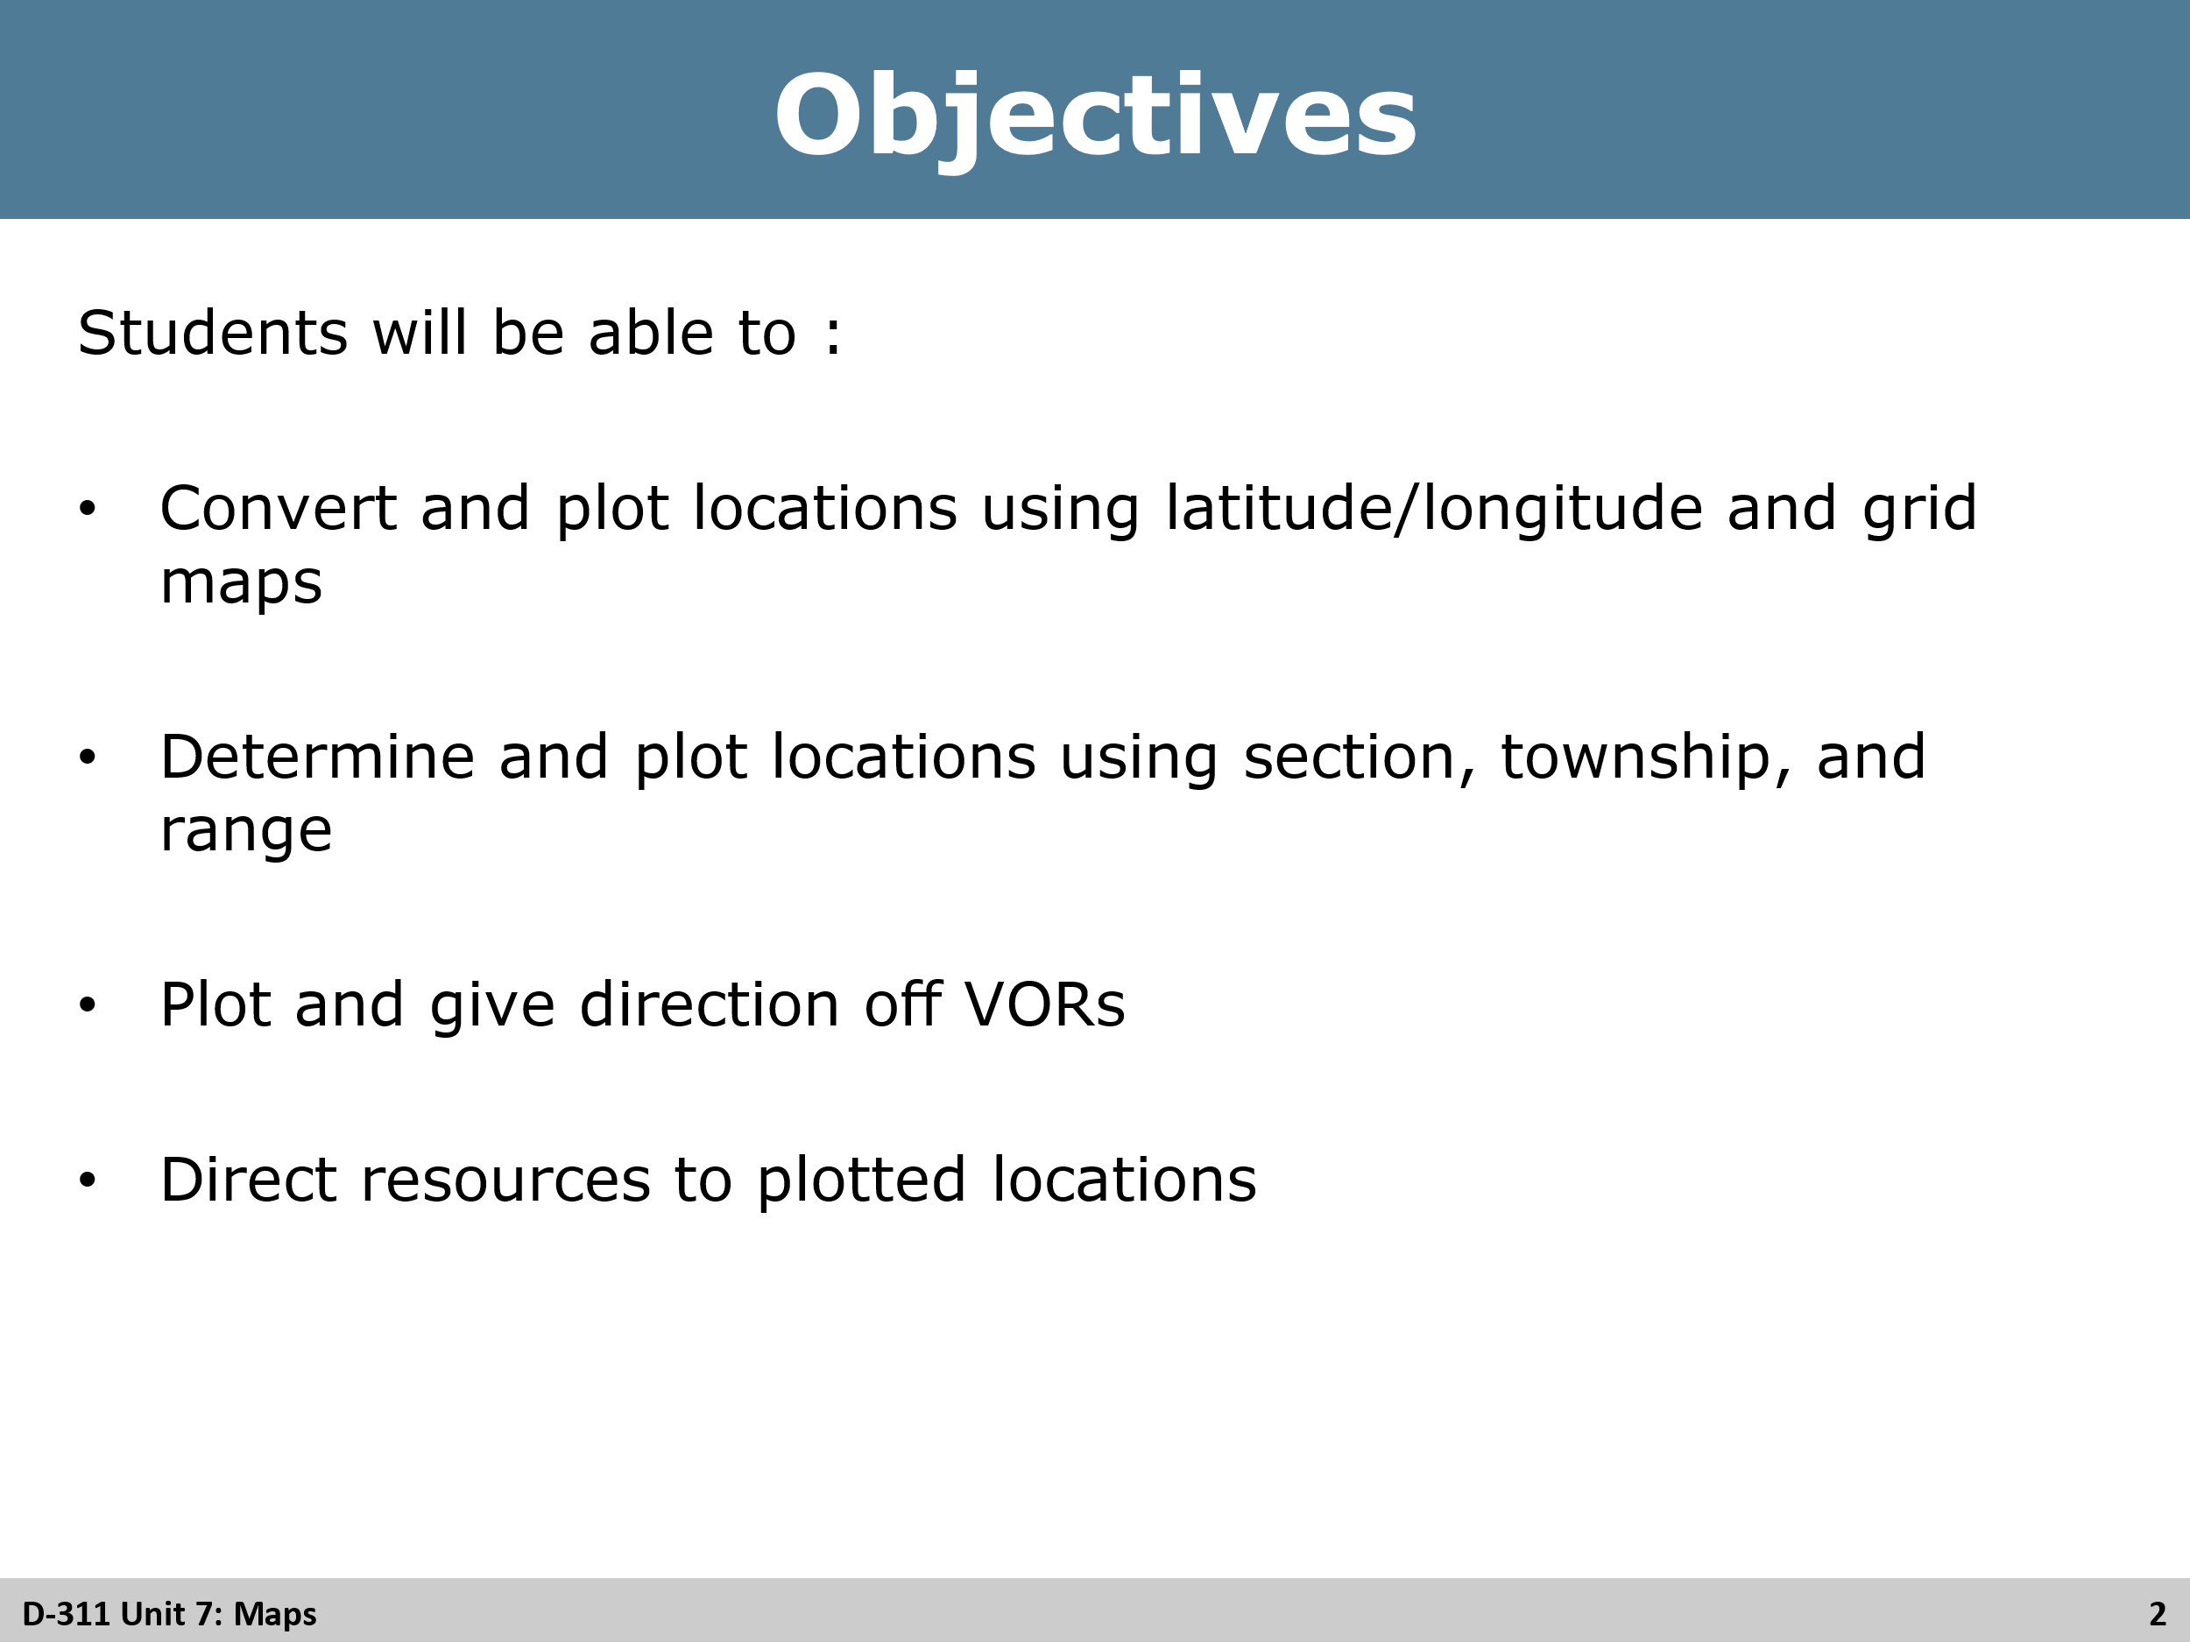
Review Unit Objectives
By the end of this unit, students will be able to:
- Convert and plot locations using latitude/longitude and grid maps.
- Determine and plot locations using section, township, and range.
- Plot and give direction off VORs.
- Direct resources to plotted locations.

Slide 3
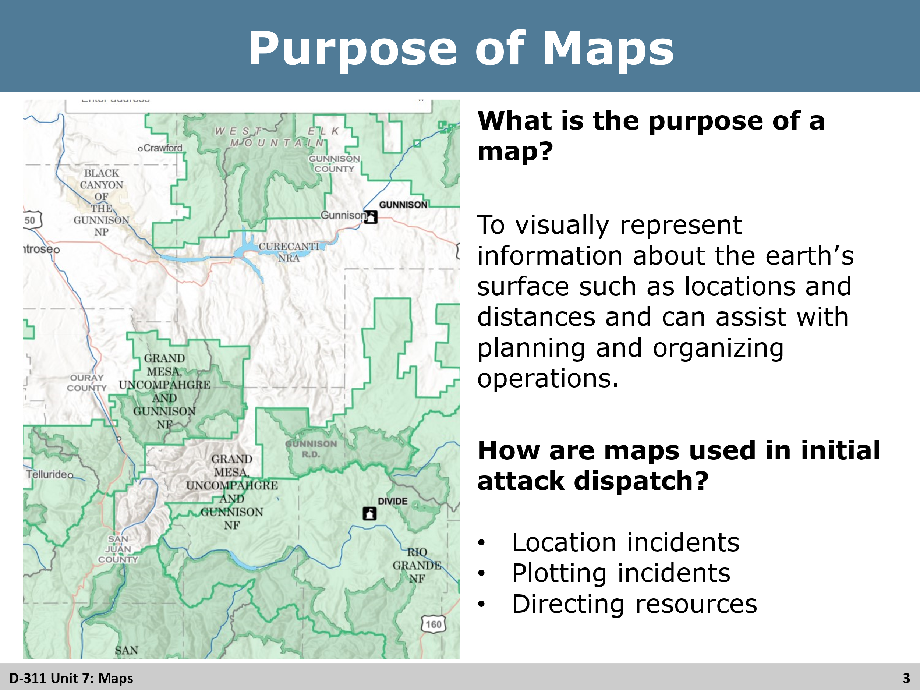
Review Purpose of Maps
What is the purpose of a map?
- Ask student what they think the purpose of map is before showing the purpose.
  - To visually represent information about the earth’s surface such as locations and distances and can assist with planning and organizing operations.
  - Definition – A graphic representation of a portion of the earth’s surface, drawn to scale on a plane.
- Ask Students to give examples of how maps can be utilized in initial attack dispatch before giving examples.
  - Location incidents
  - Plotting incidents
  - Directing resources

Slide 4
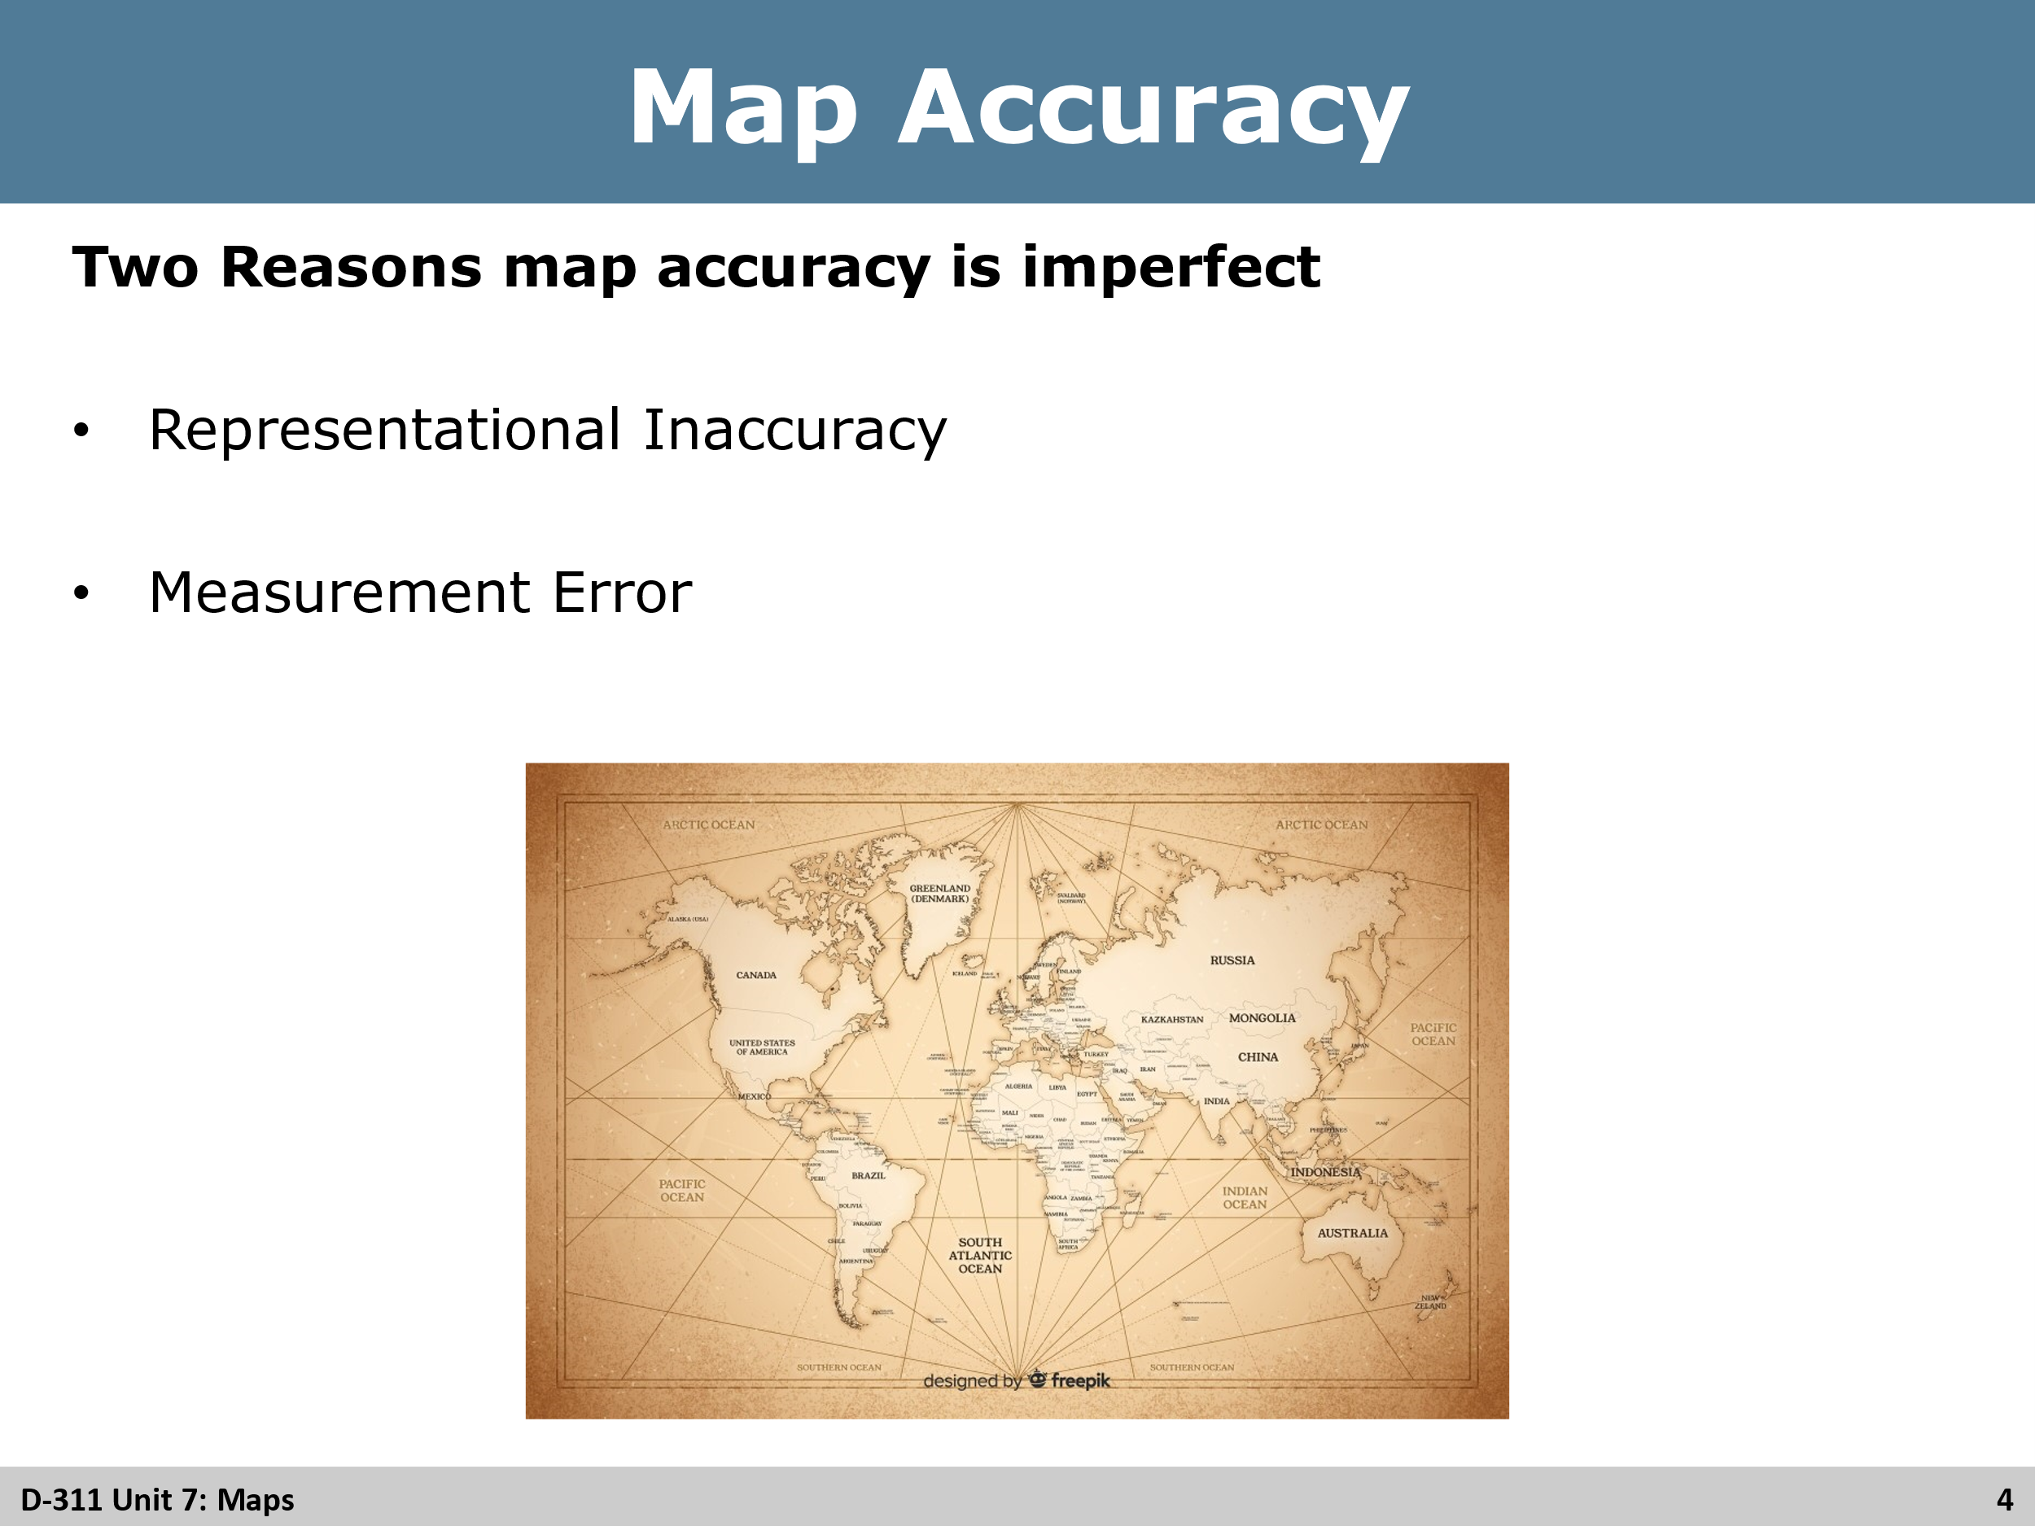
Review
Give students examples of imperfections
Representational Inaccuracy
- Due to curvature of the Earth
- Uneven surface on a flat piece of paper
- Erroneous local information
Measurement Error
- Human Error
- Inadequate survey procedures and equipment used

Slide 5
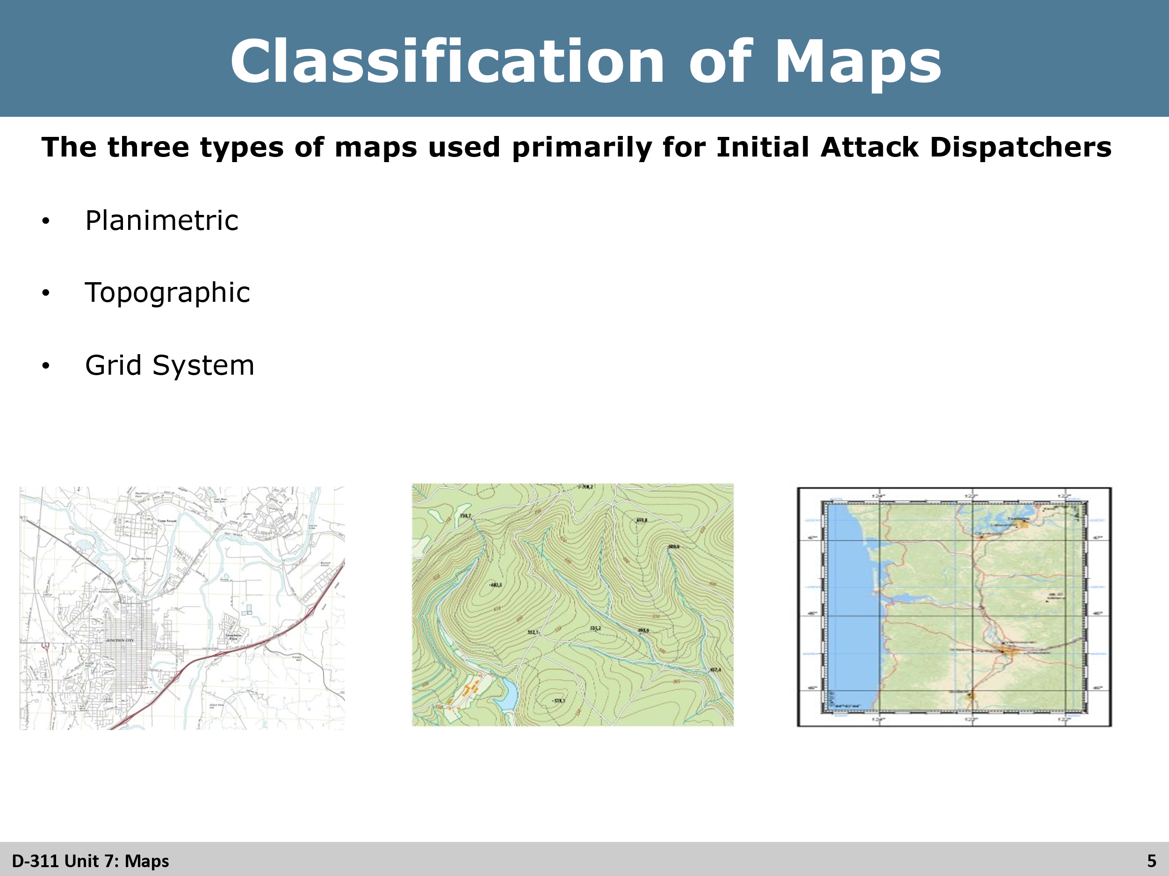
Review
Review slide with students.

Slide 6
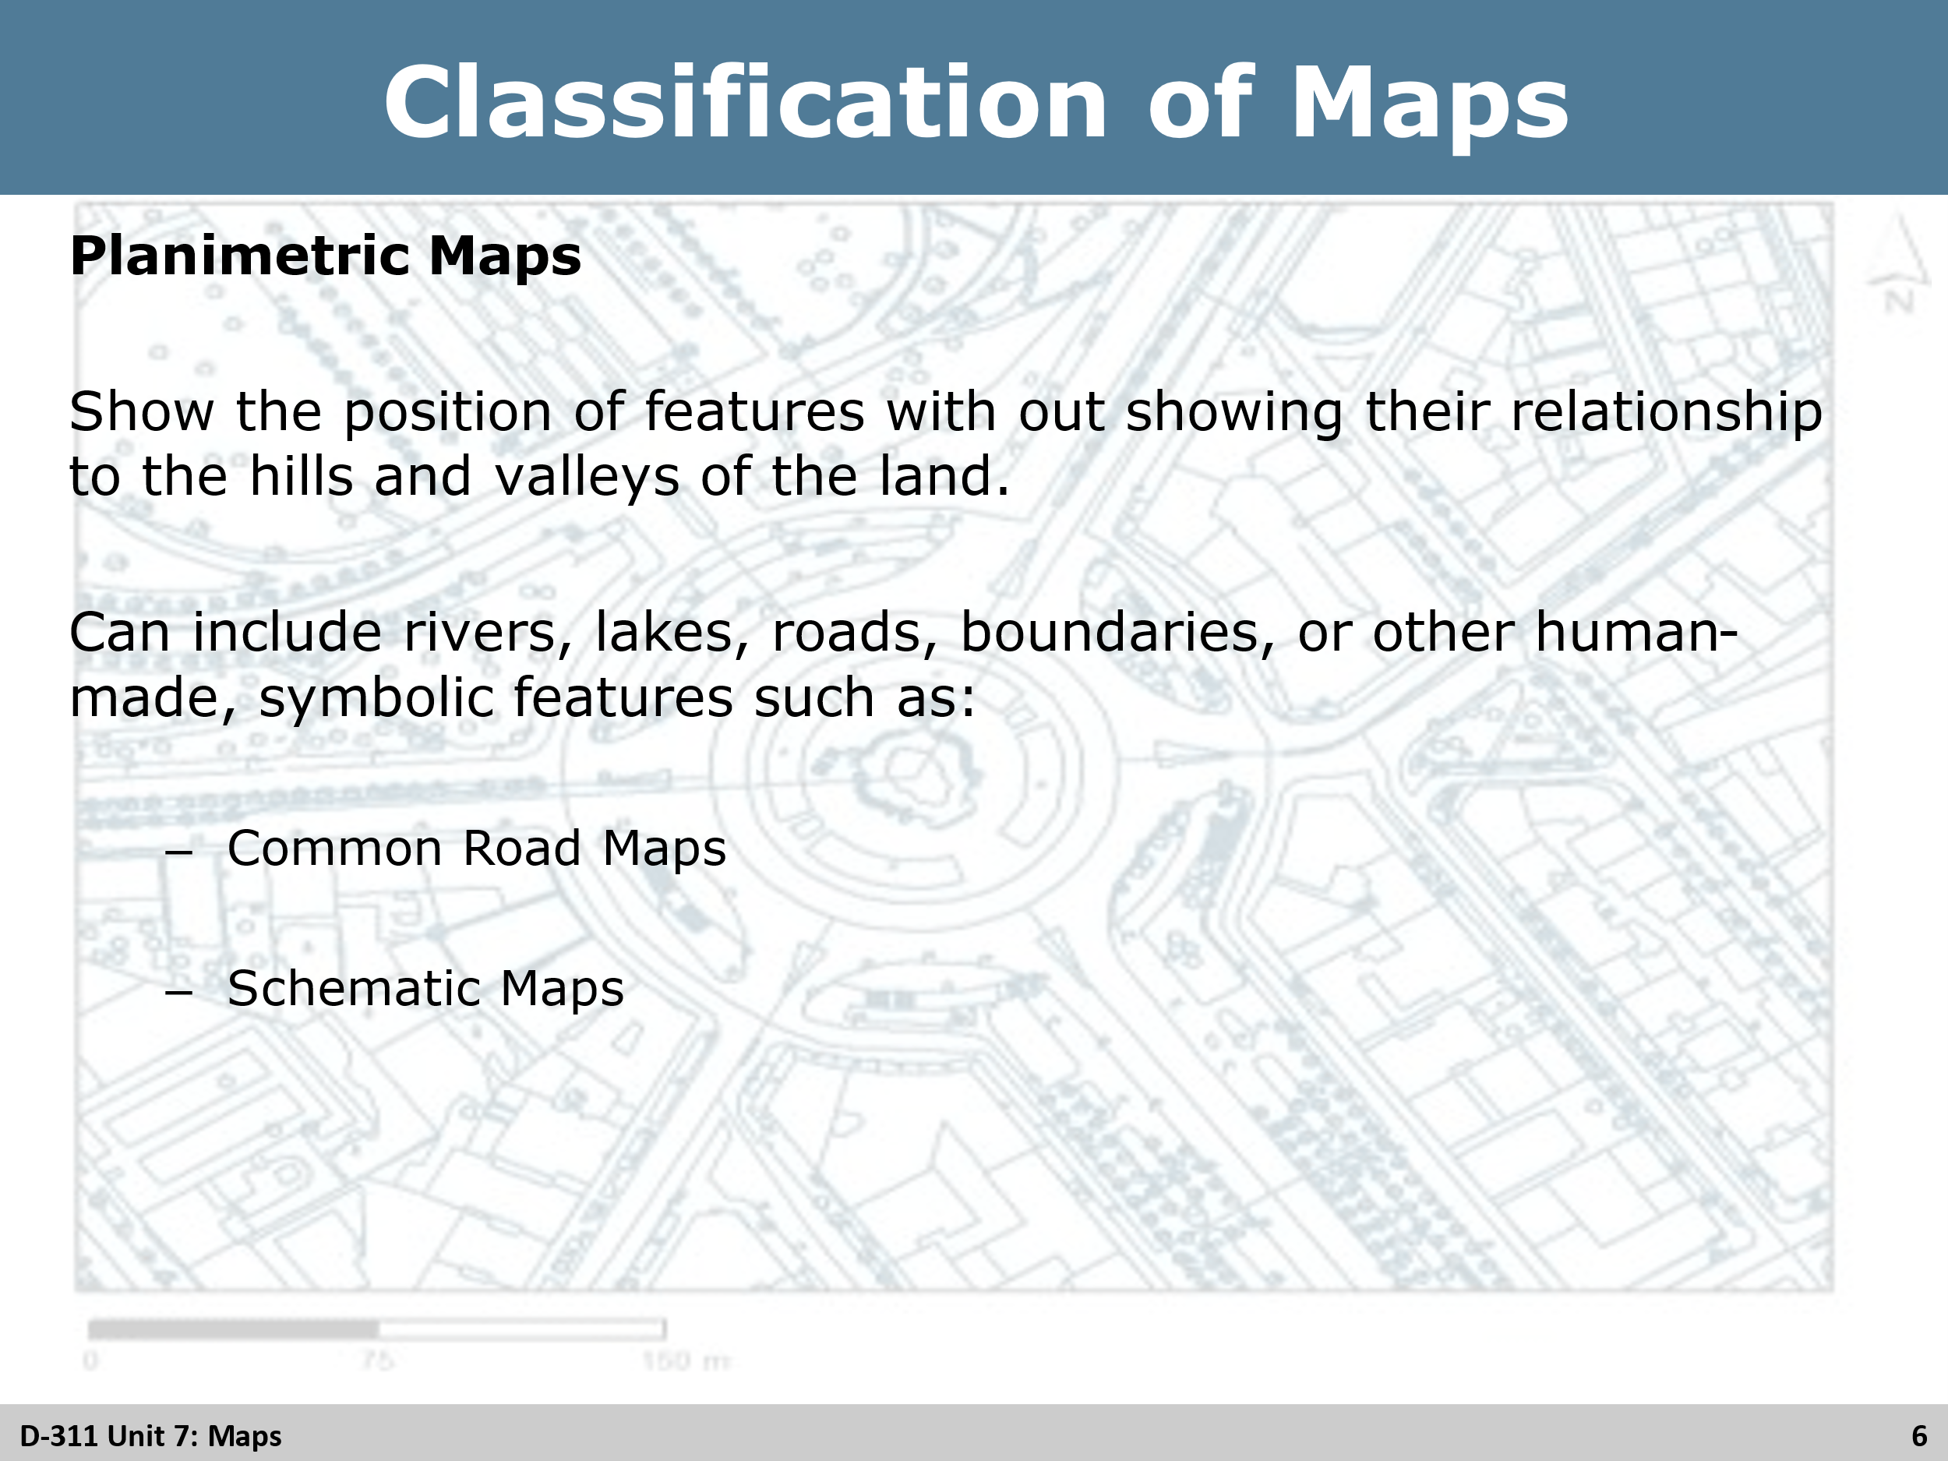
Group Discussion
Planimetric Maps: Ask the students to name some common examples of each type of map.
Road Maps
- Road atlas
- Street atlas
- State maps
- Thomas guides
Schematic Maps
- Agency maps
- Unit maps
- Neighborhood planning maps
- Aviation maps
- Resource and district response maps

Slide 7
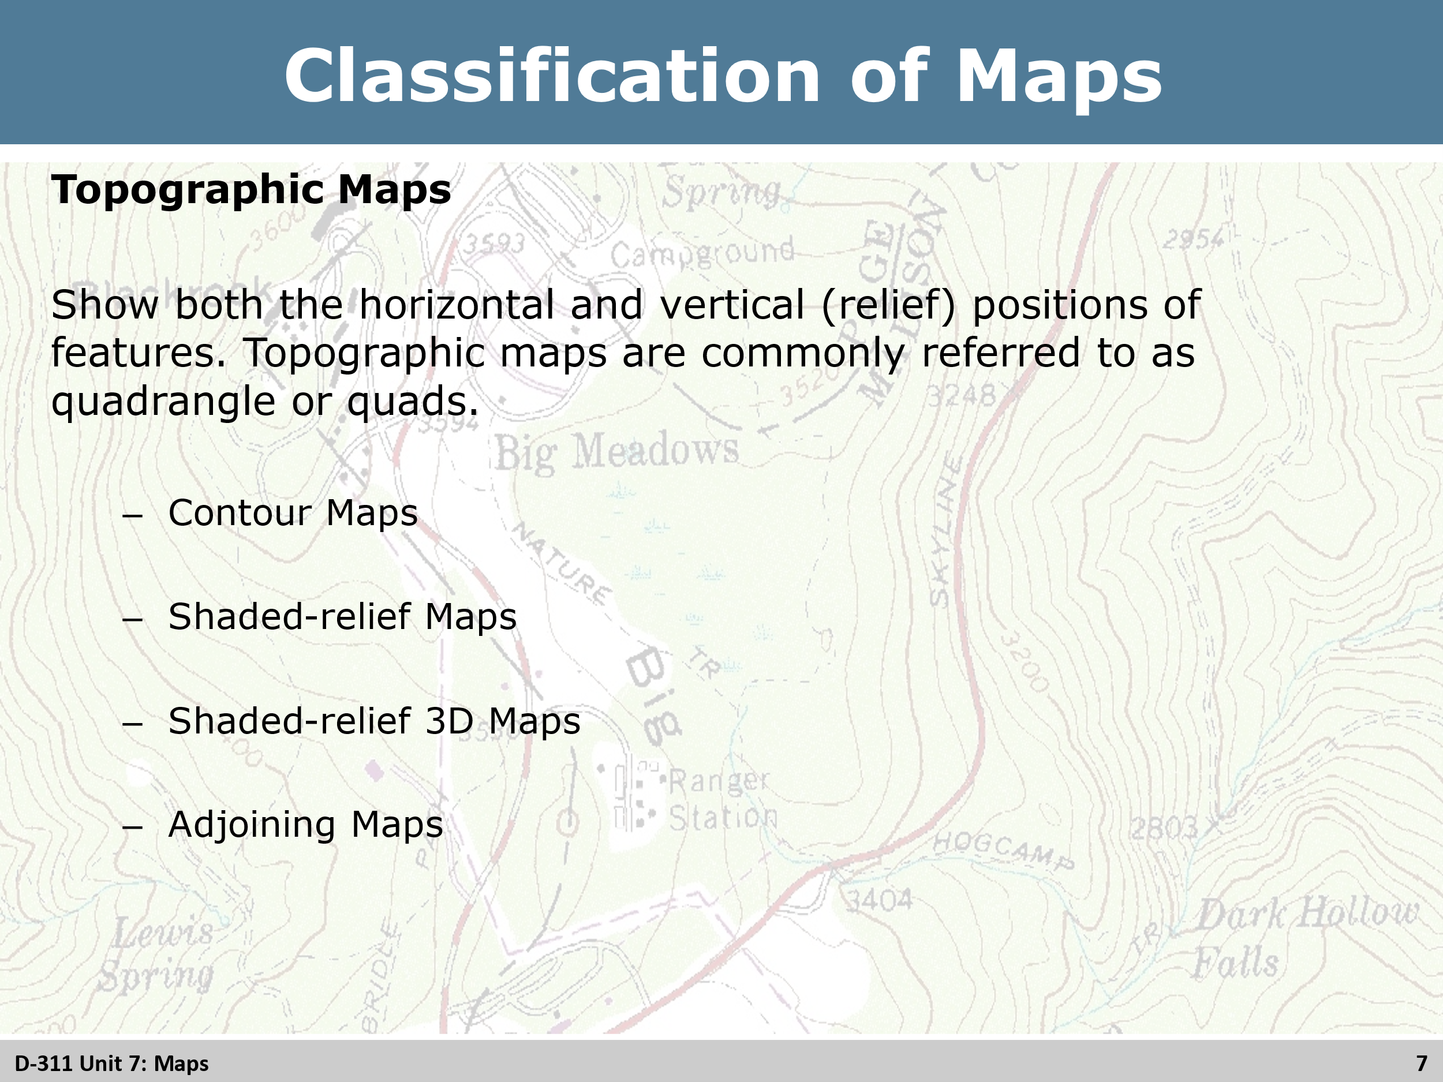
Group Discussion
Topographic Maps: Discuss the differences of the topographic maps with the students
Contour
- Most common representing the shape and elevation of a section of land.
- A contour line is equal elevation on the ground that delineates the same elevation above or below a specific reference elevation, usually sea level.
Shaded-relief
- Are pictorial and shaded to simulate sunlight on the terrain.
- Shadow affect accentuates the shape of the physical features such as ridges, valleys, and tops.
Shaded-relief 3D
- Exaggerate the landscape to enhance the features.
Adjoining
- One or more map too large to be shown on a single map.
- Adjoining maps are frequently indicated in the margins of United States Geological Survey (USGS) topo maps, or by an adjoining quadrangle legend on the map.
- Computerized adjoining maps can be seamless.

Slide 8
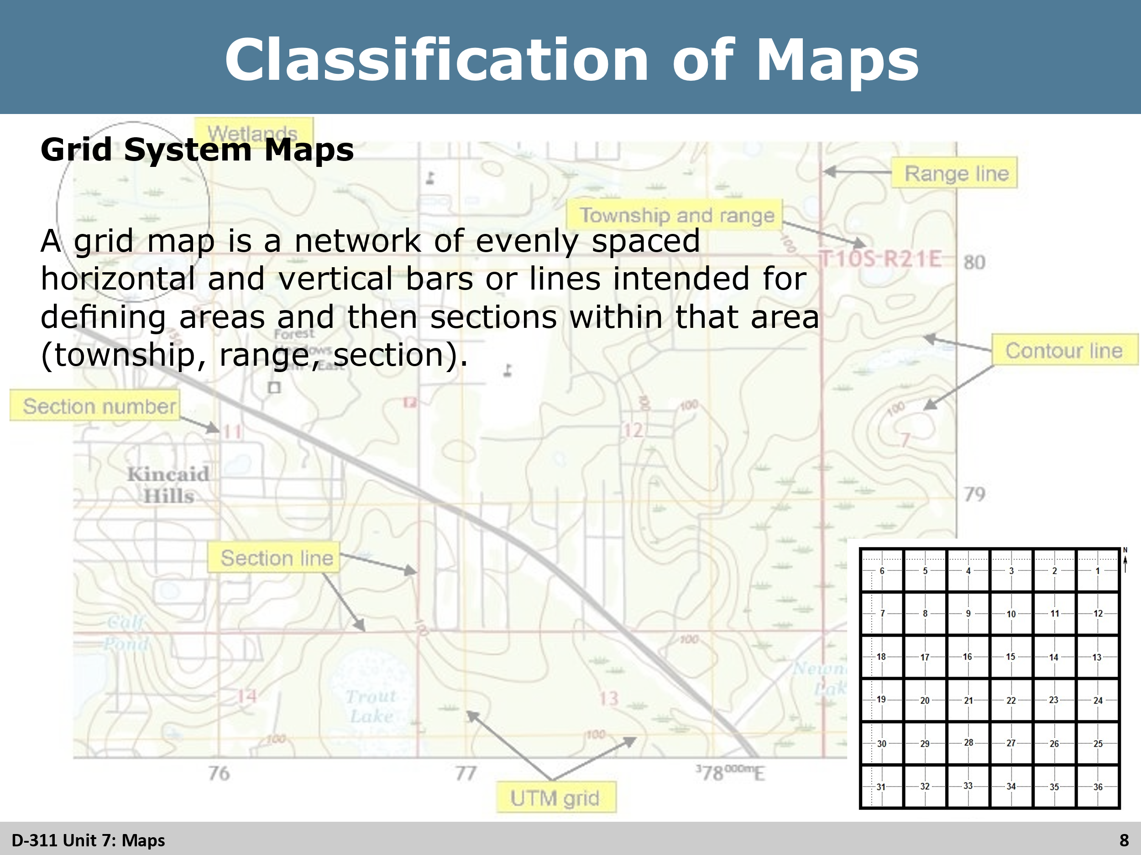
Group Discussion
Grid System Map: Discuss the types of grid system maps to the students.
- Local administrative maps
- Road atlas
- Agency (Dispatch maps)

Slide 9
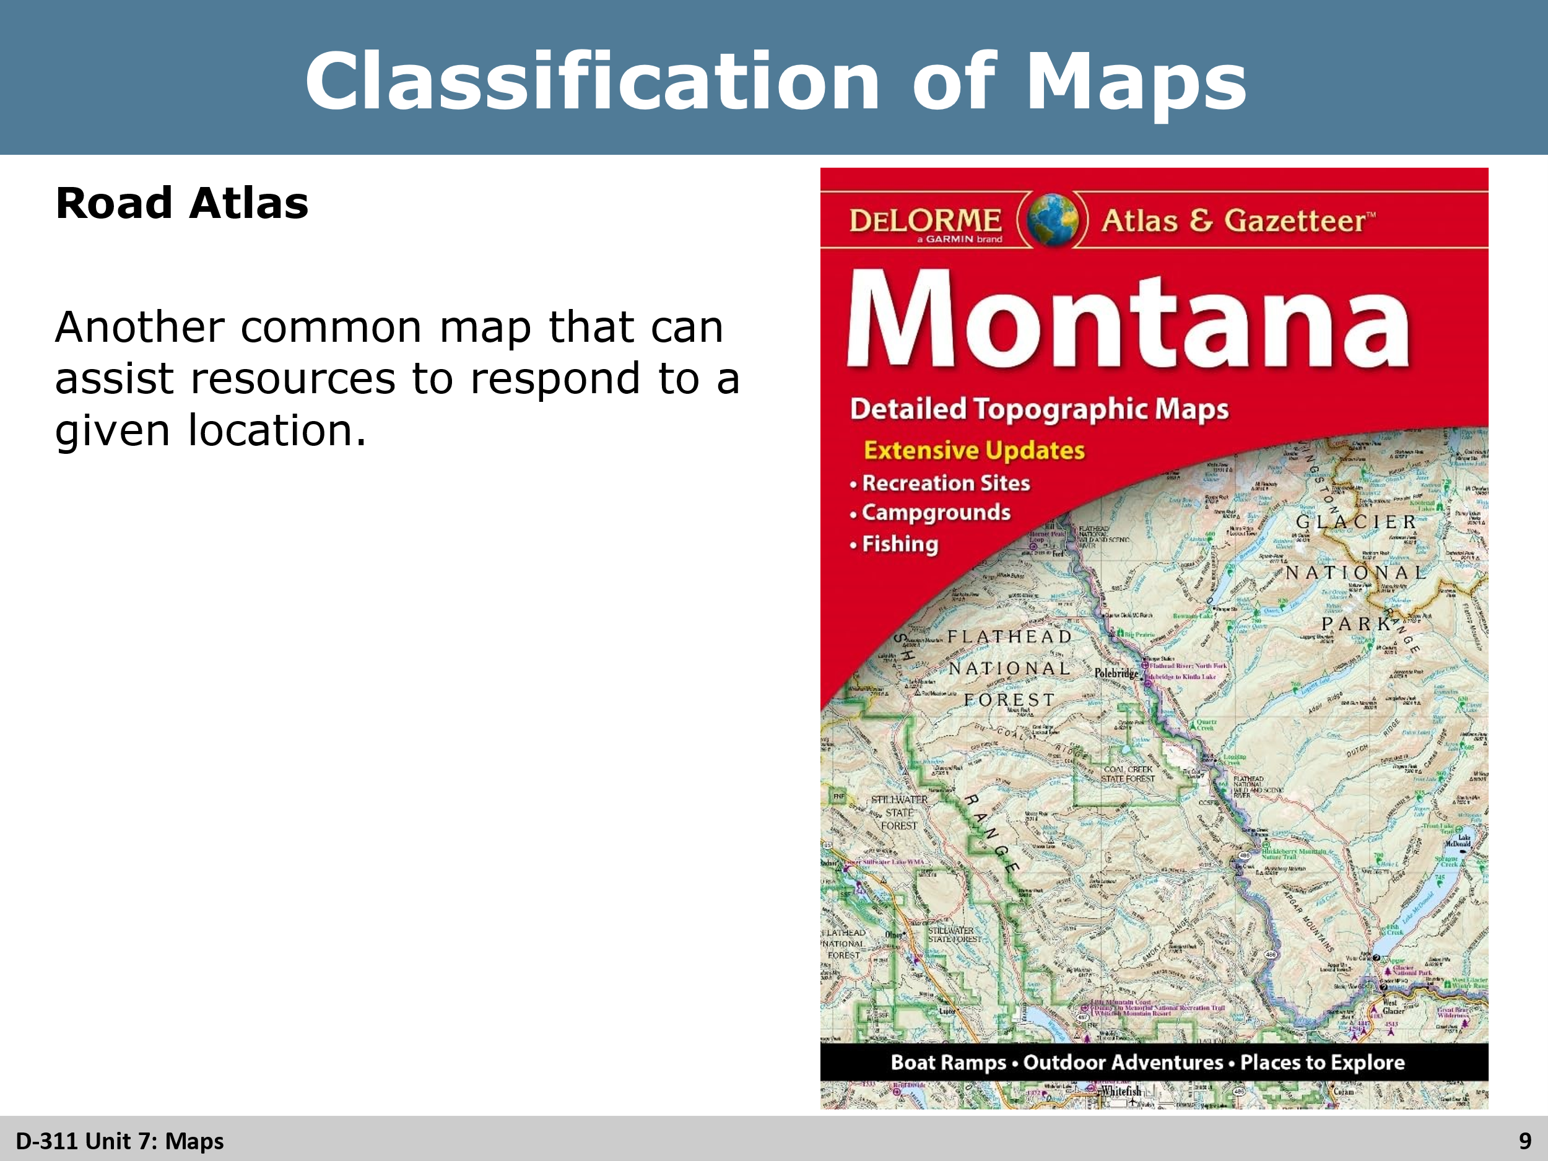
Group Discussion
Road Atlas: General purpose maps
- Cities and communities
- Highways, interstates, and points of interest
- Key Map located at the front of the atlas and is the primary guide. It will give an overall view of the area the atlas depicts.

Slide 10
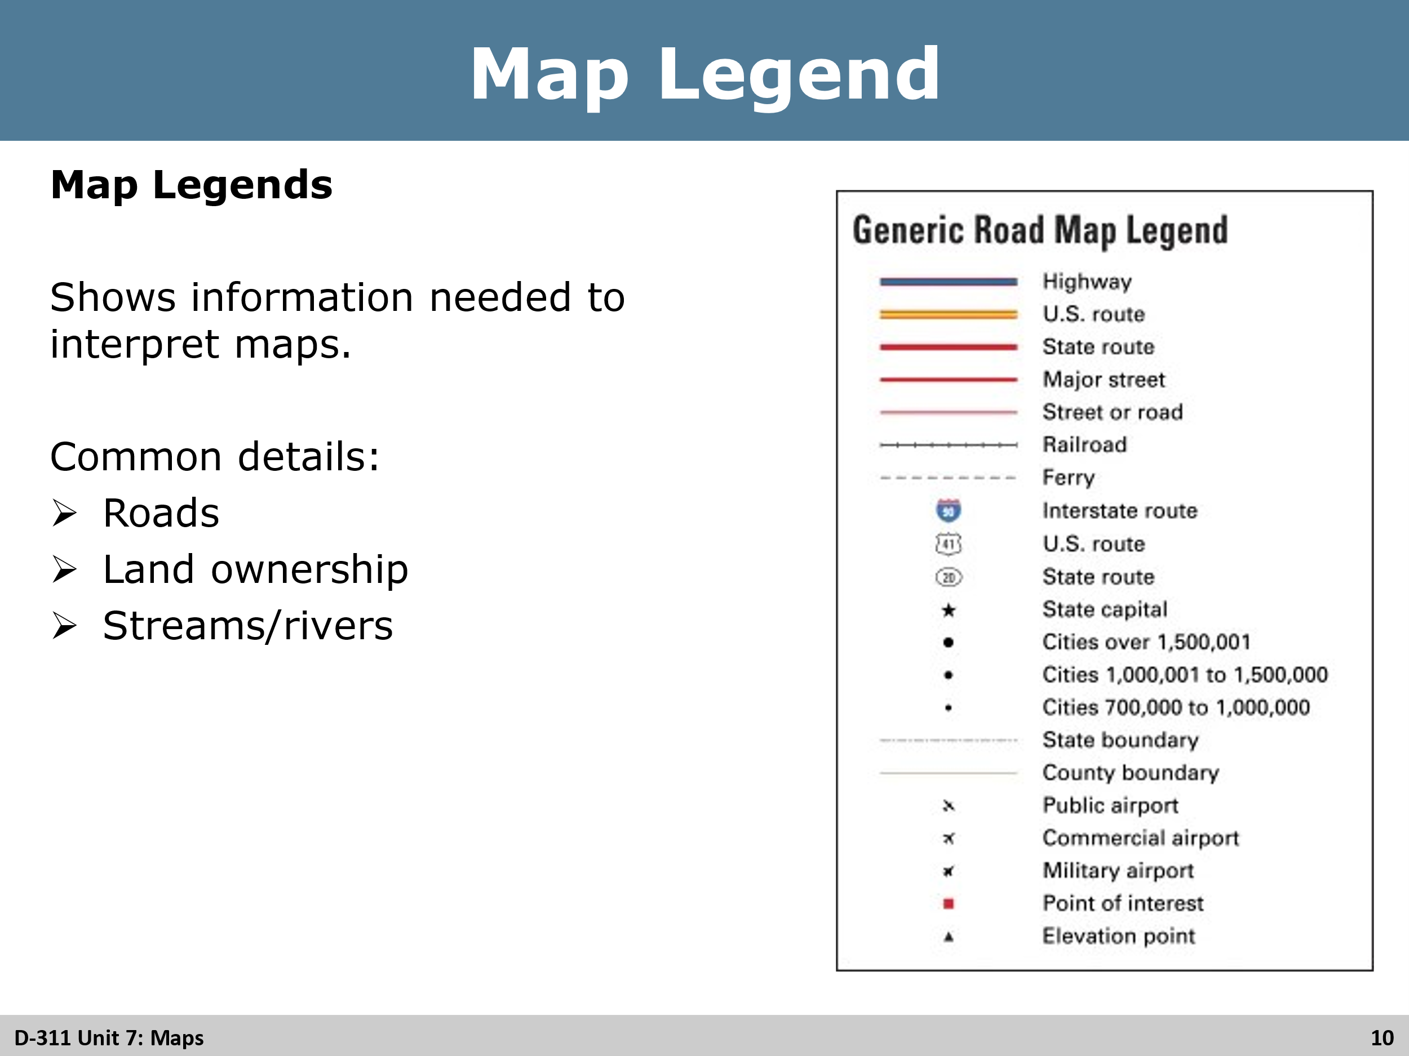
Review
Ask the students for examples as to what could be on a legend.
Common examples:
- Heliports
- Airports
- Hazards
- Lakes, rivers, streams
- Parks

Slide 11
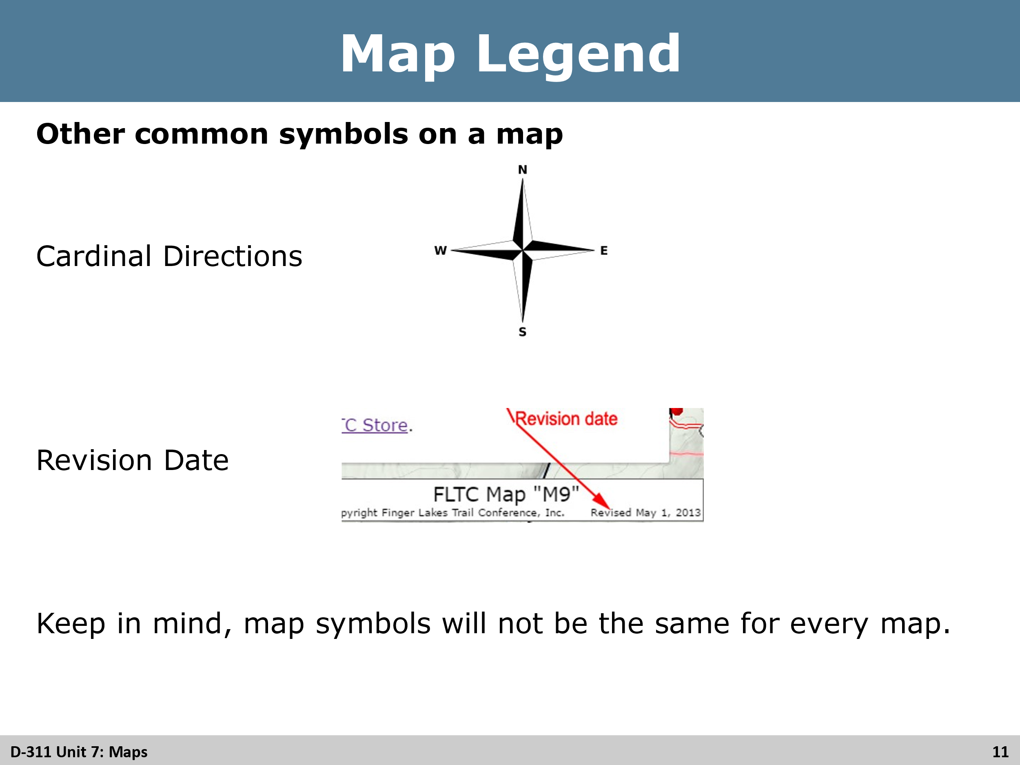
Review
Review other common symbols. Ask students if there are any other common symbols that may be found on a map.

Slide 12
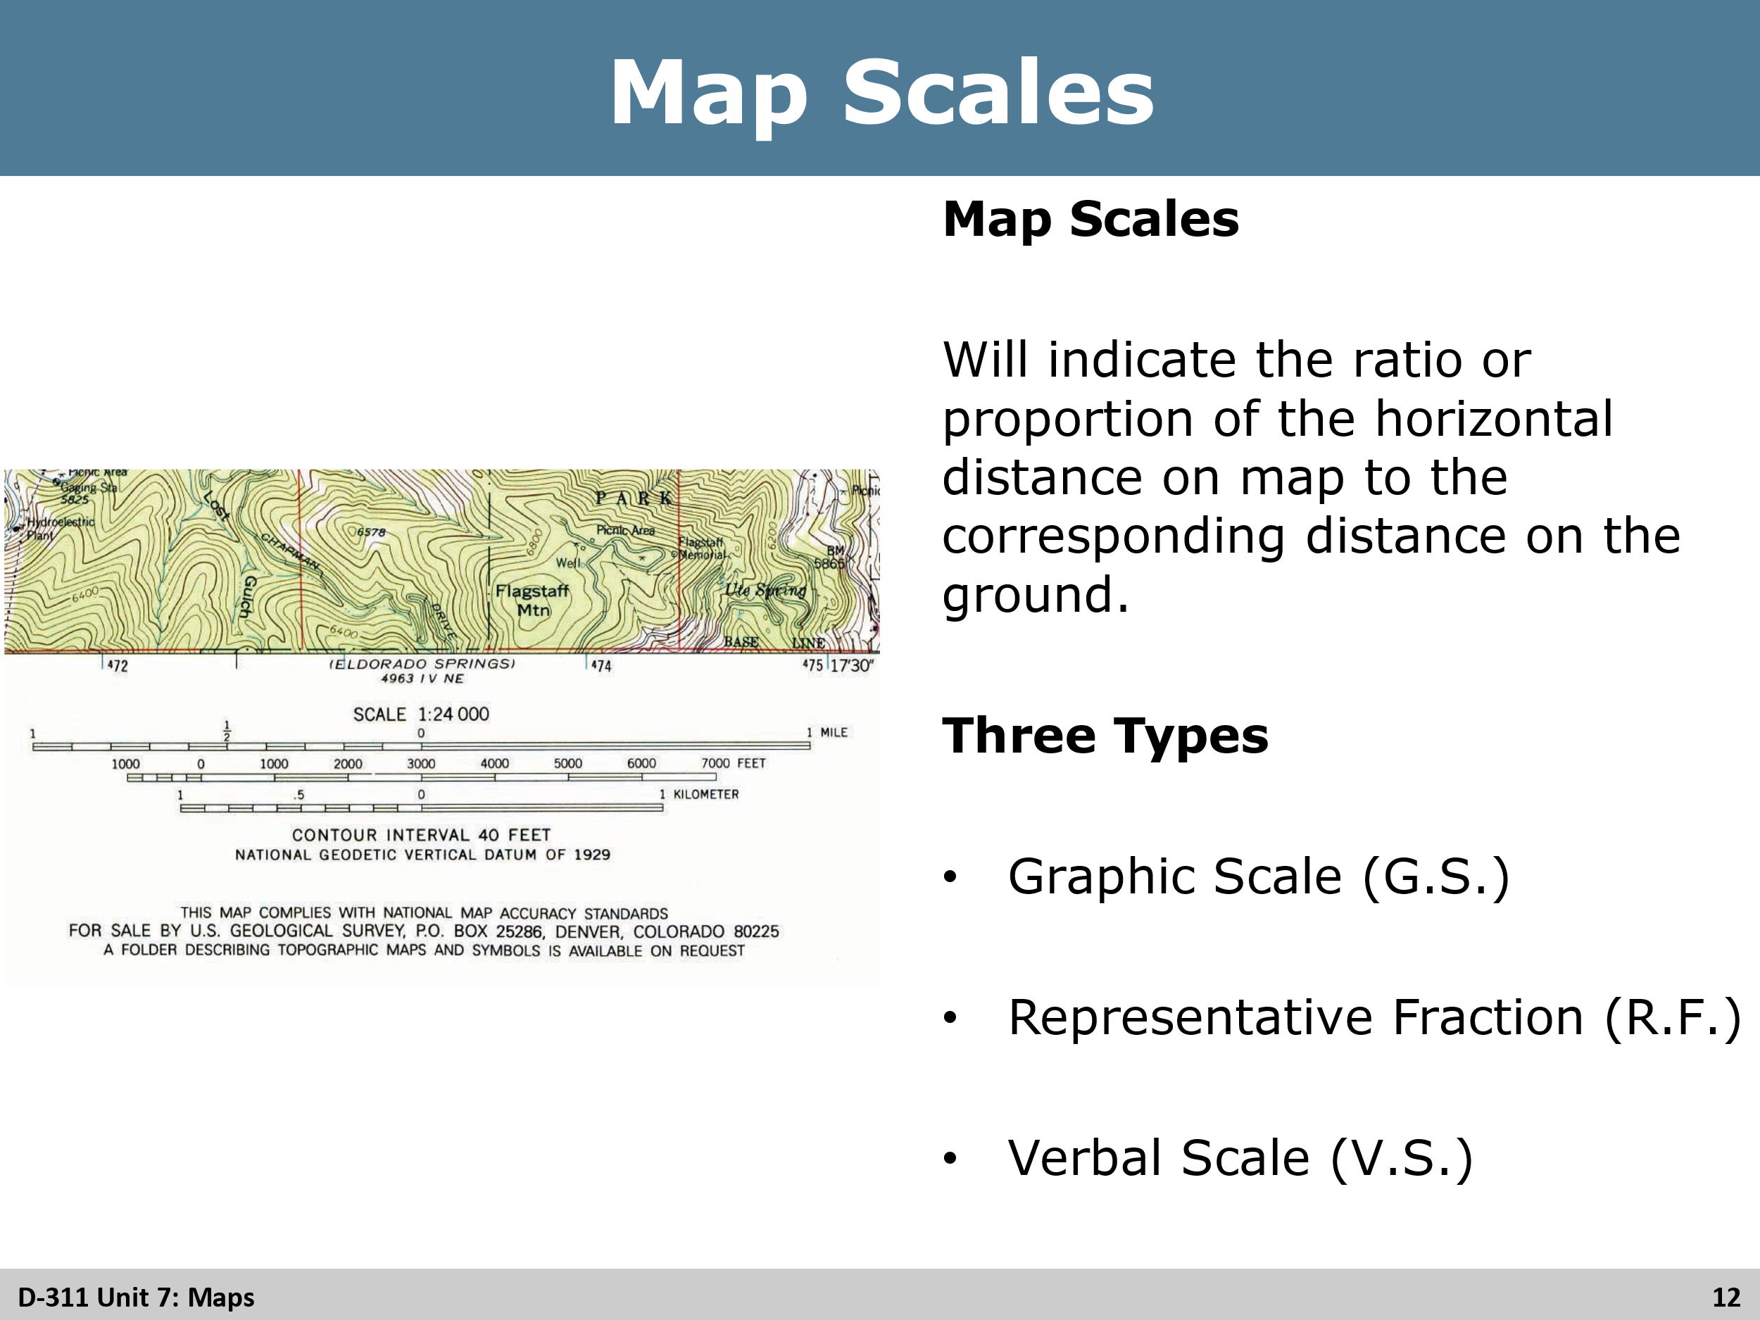
Review
Review with the students what the scales are and they three common scales.
- Graphic Scale
- Representative Scale
- Verbal Scale

Slide 13
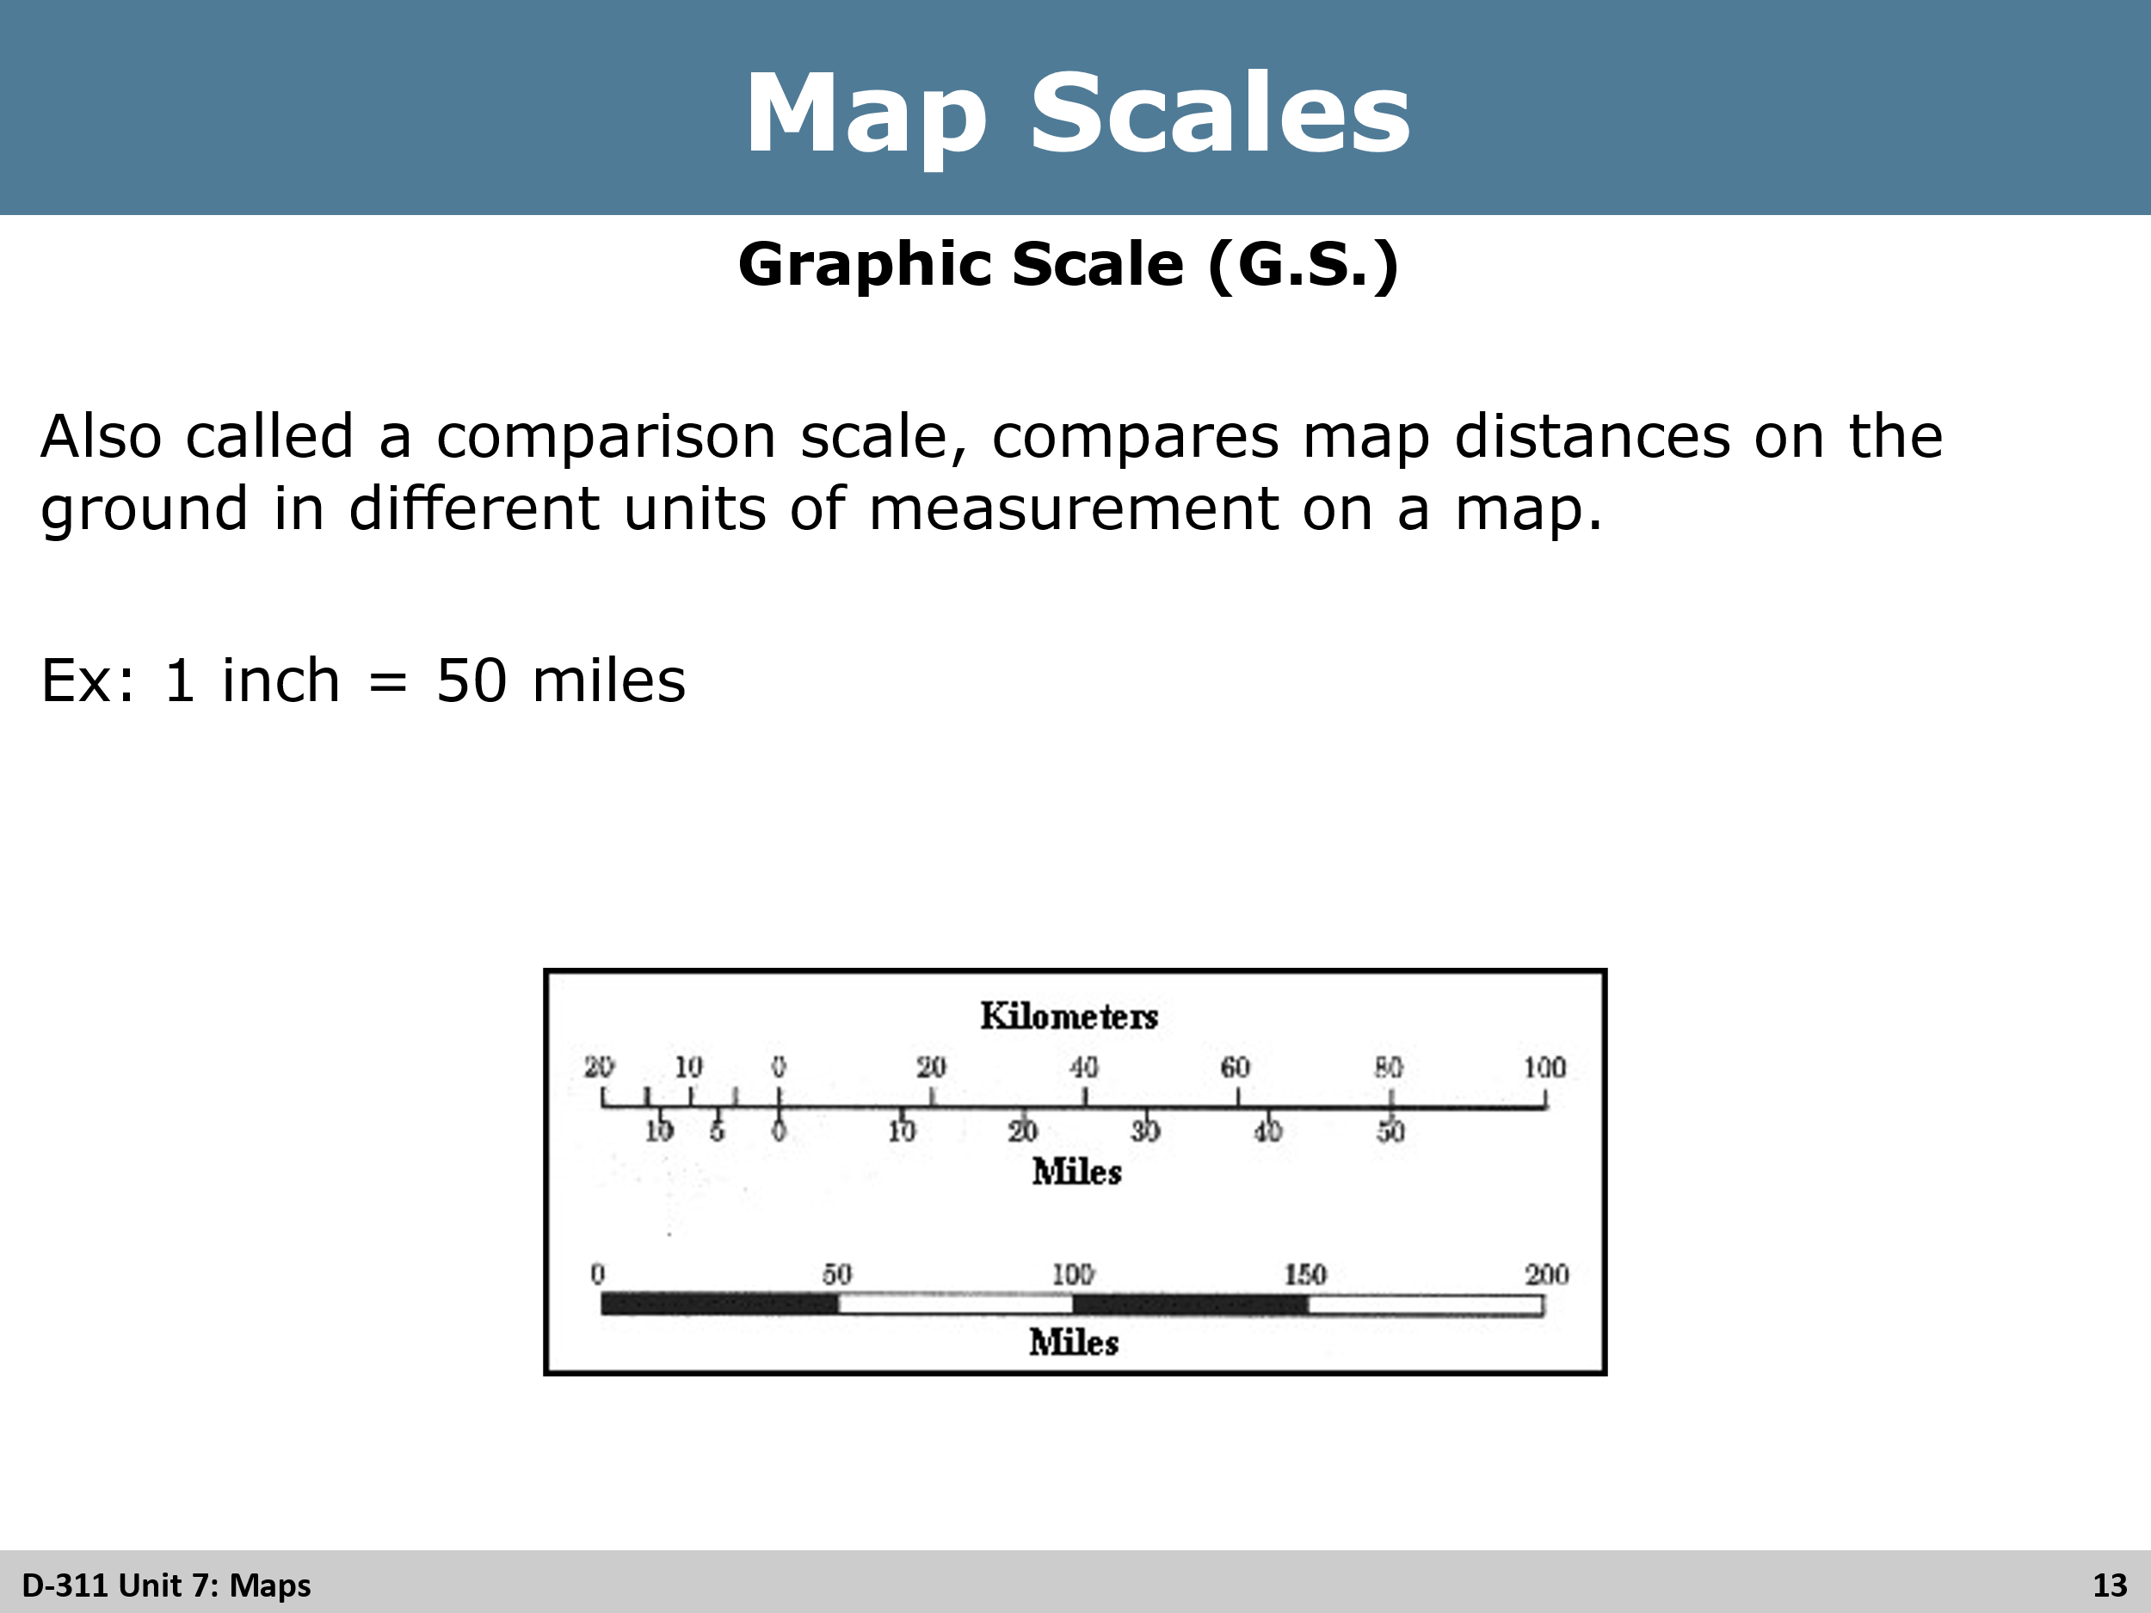
Review
Review Graphic Scale with the students.

Slide 14
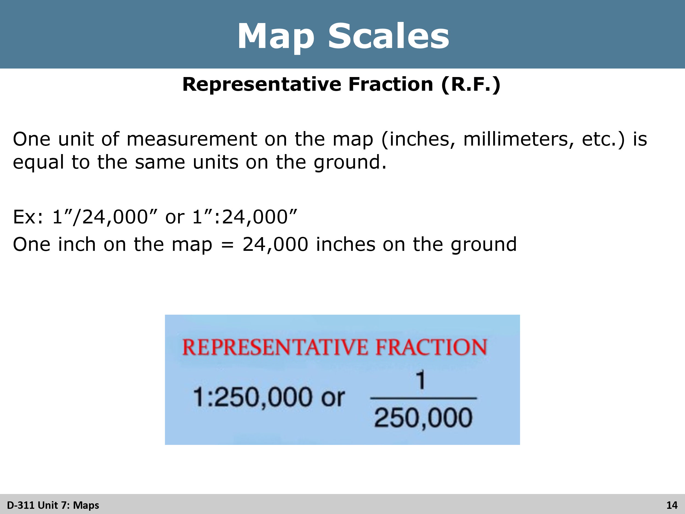
Review
Review Representative Scale with the students.

Slide 15
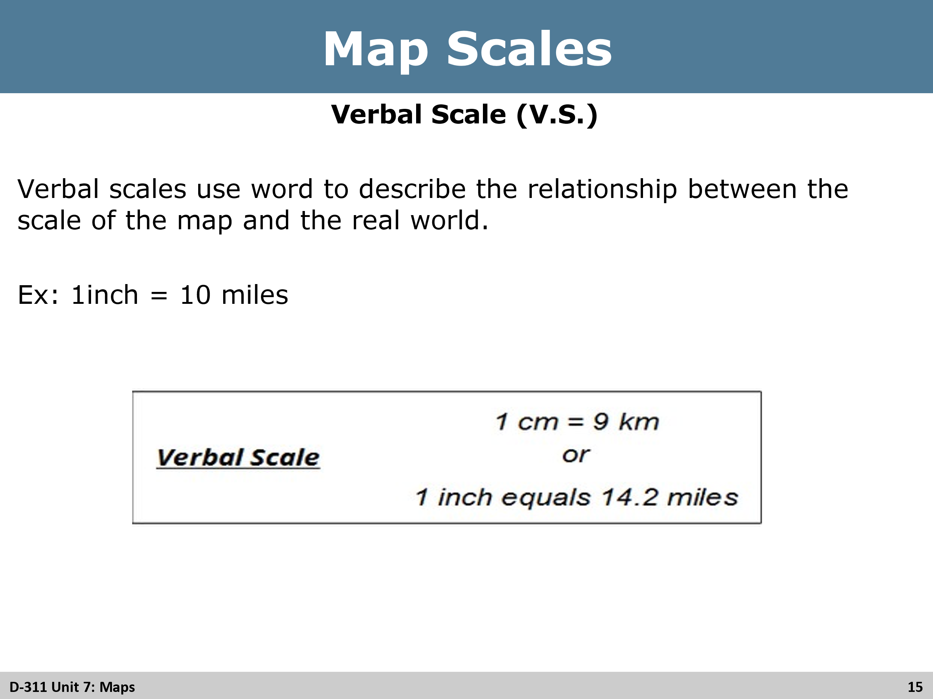
Review
Review Verbal Scale with the students.

Slide 16
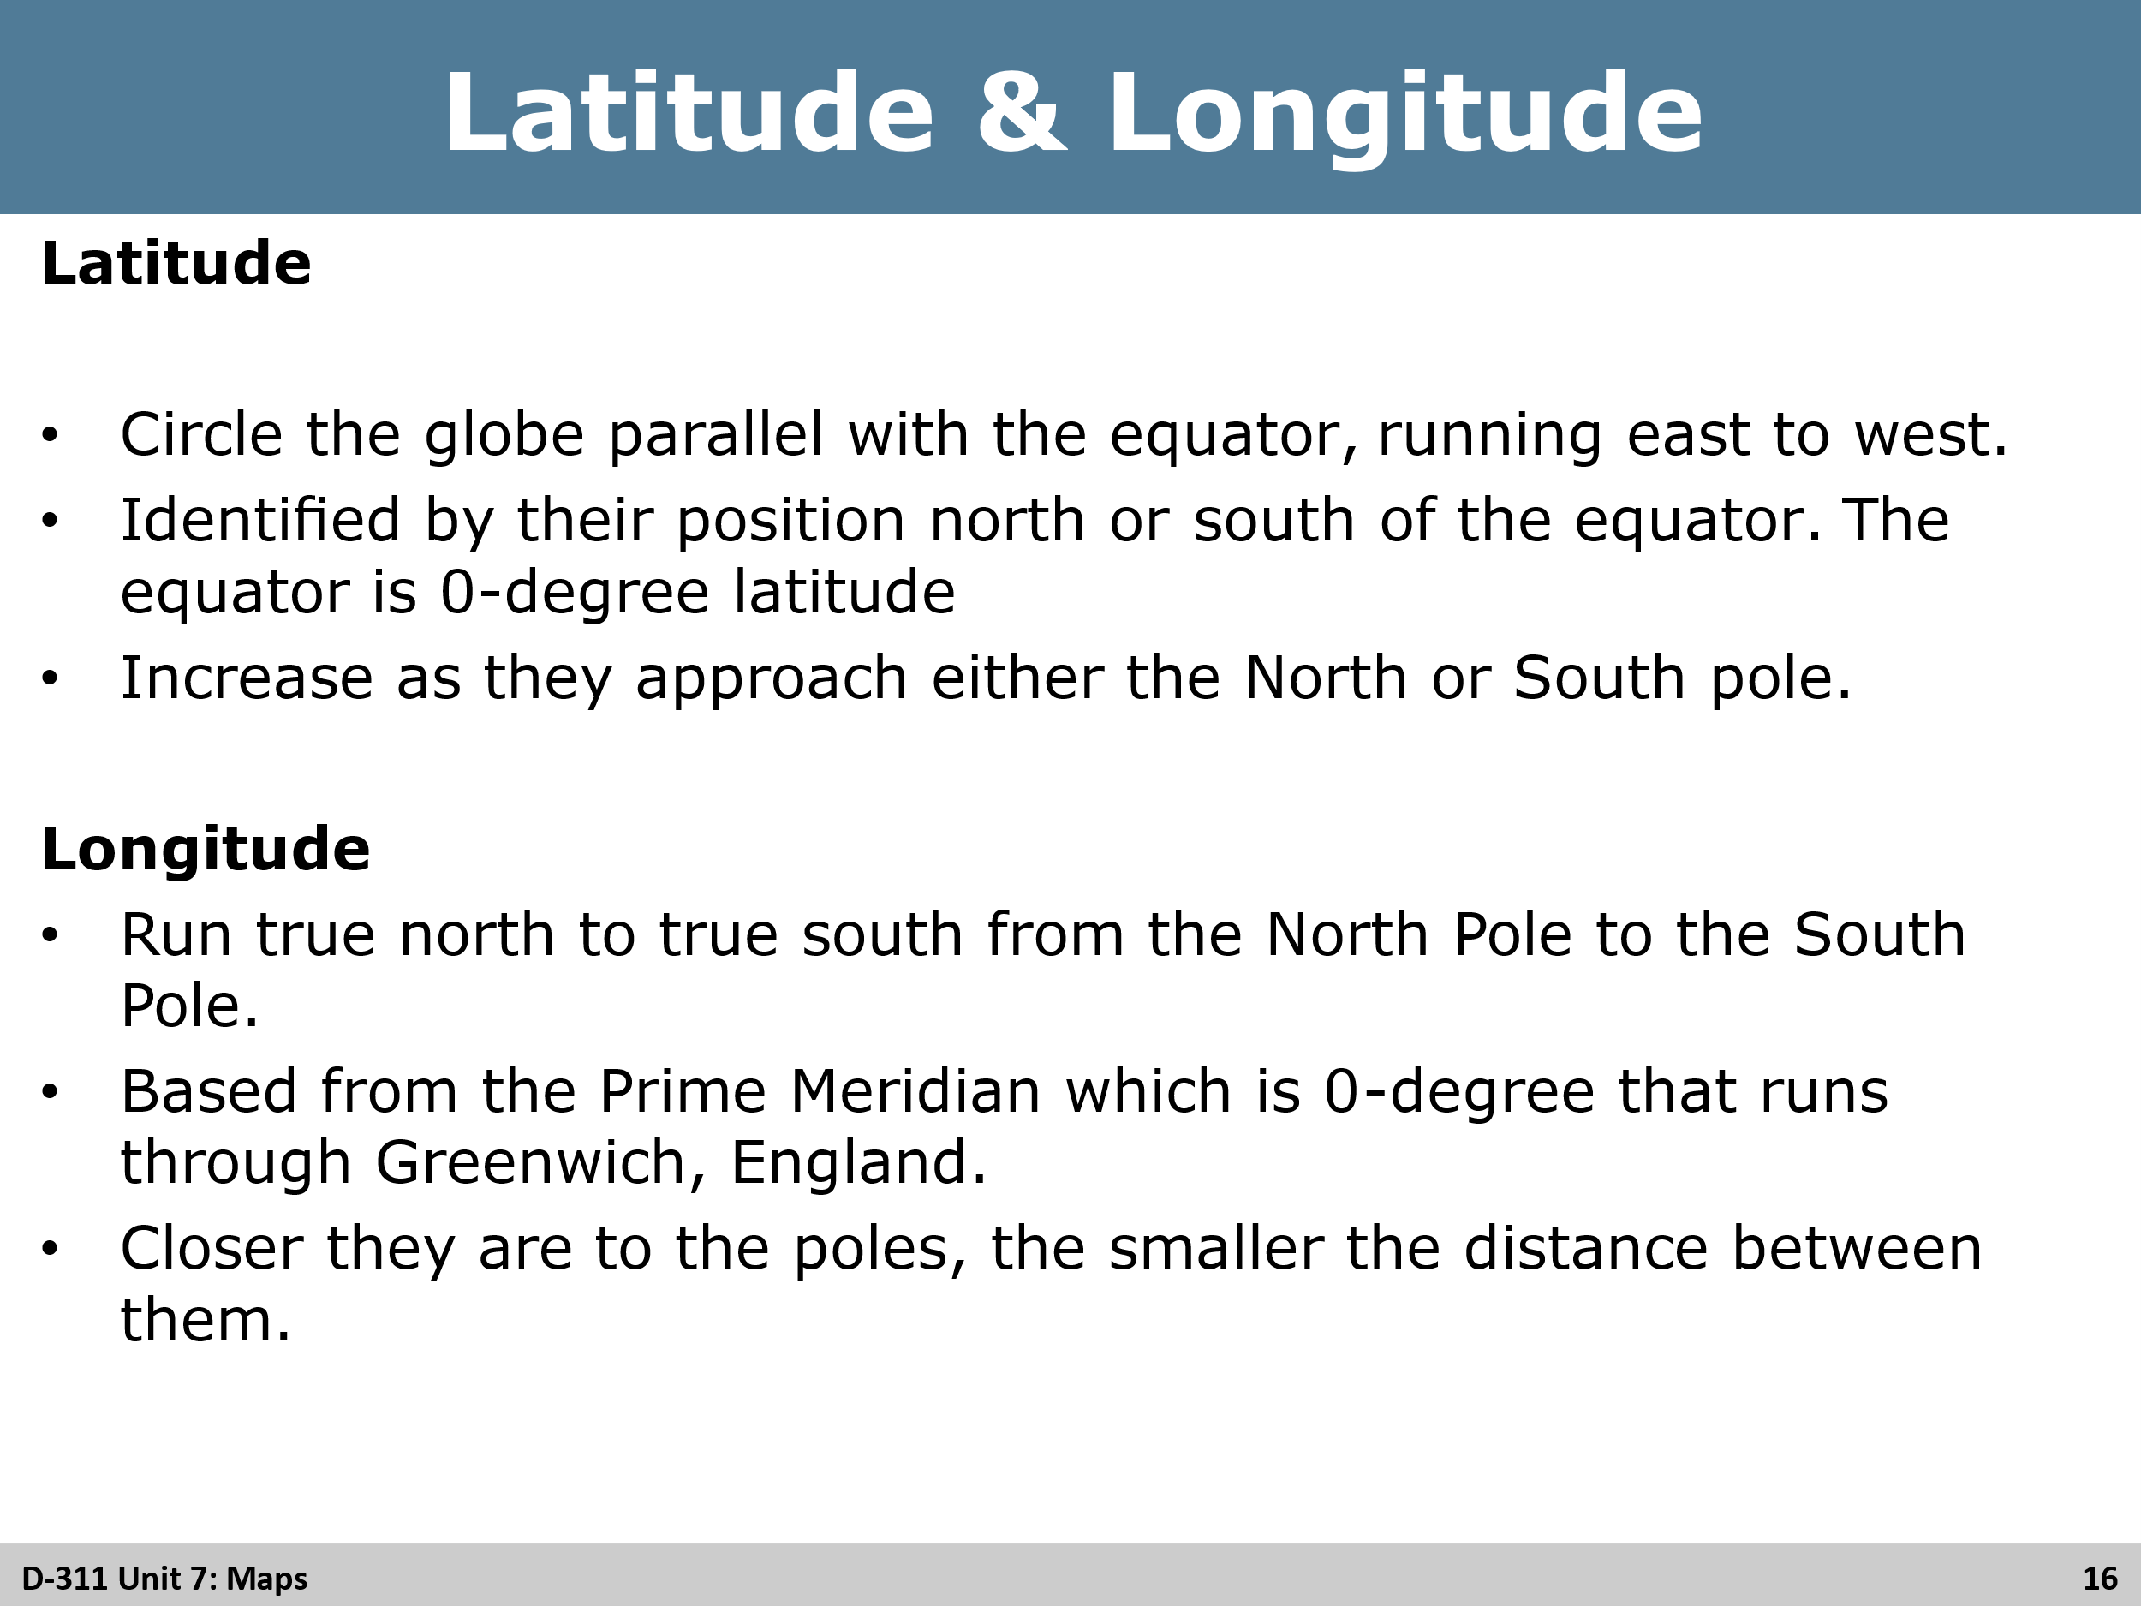
Review
Review both latitude and longitude with the students.

Slide 17
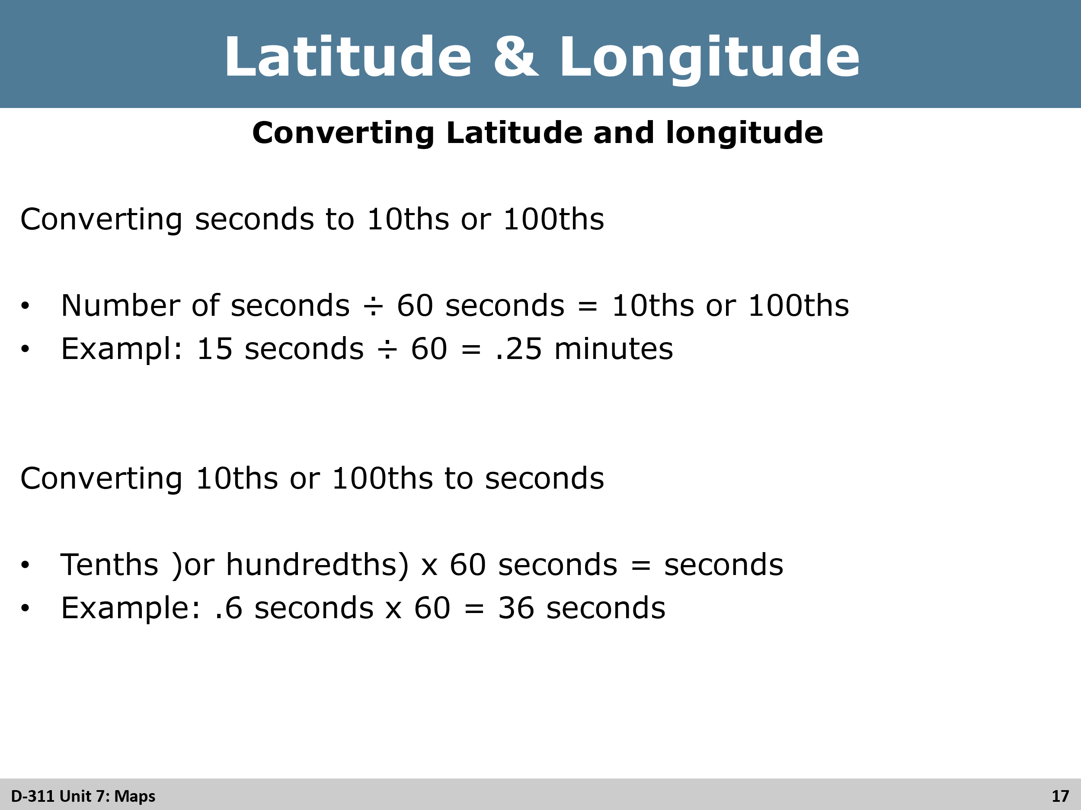
Review
Review the equations with the students.

Slide 18
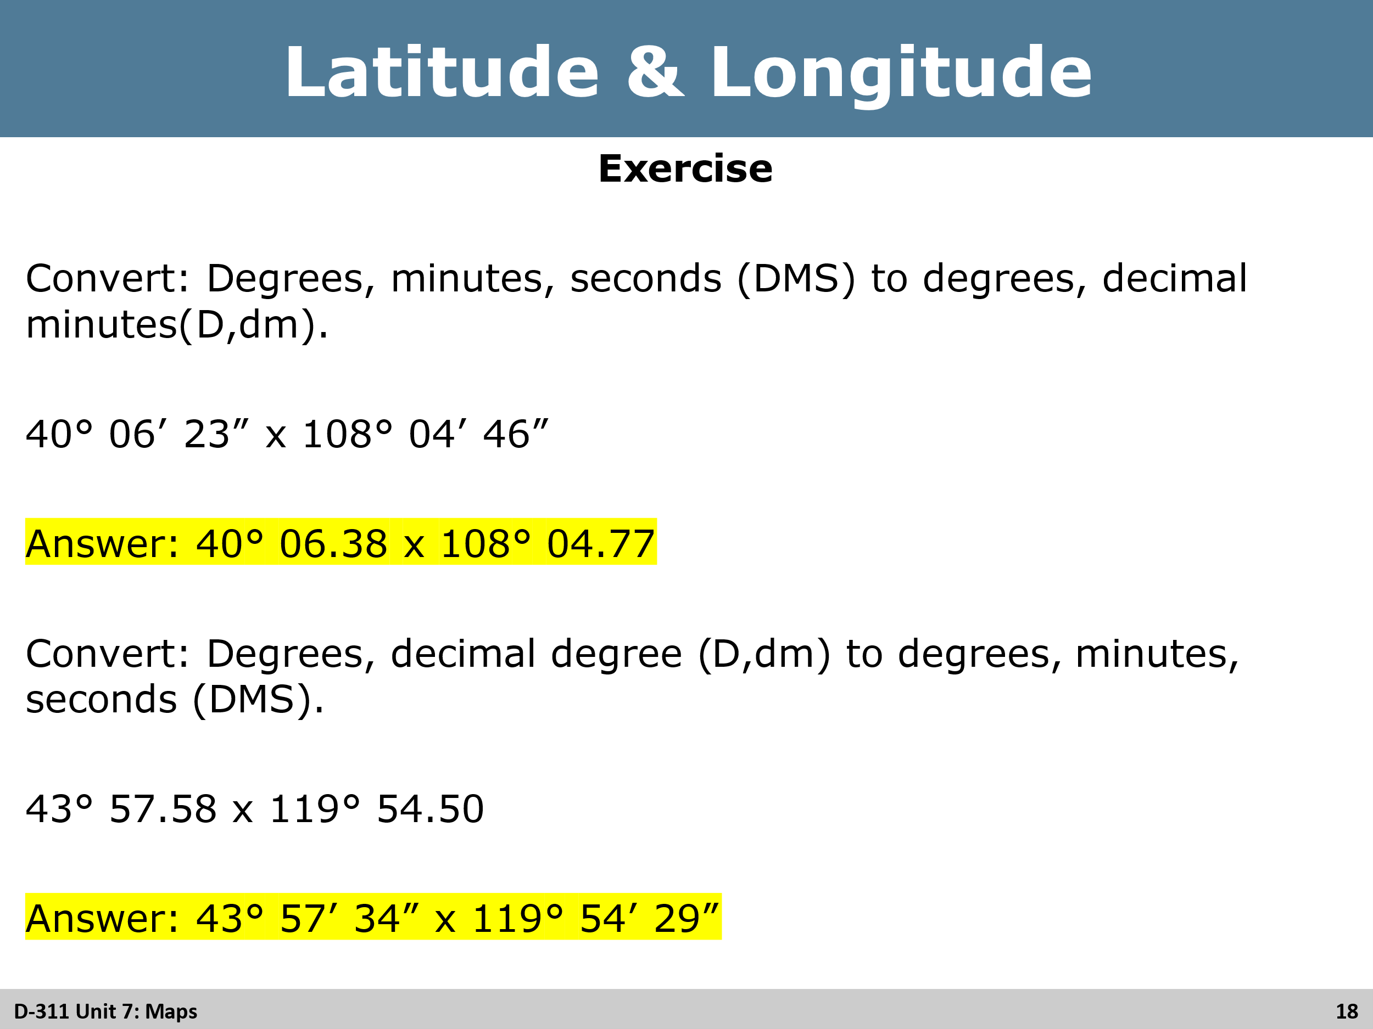
Activity
Have the students complete the two conversions (15 minutes). Show the answers and compare with the students answers after time has passed.

Slide 19, 20, 21
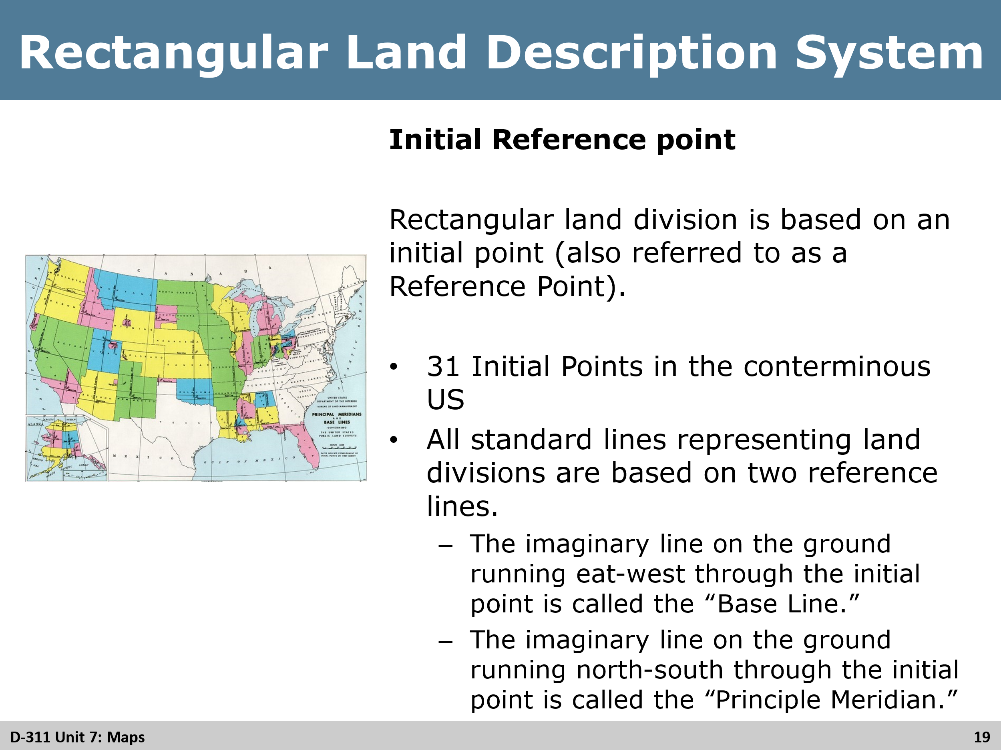
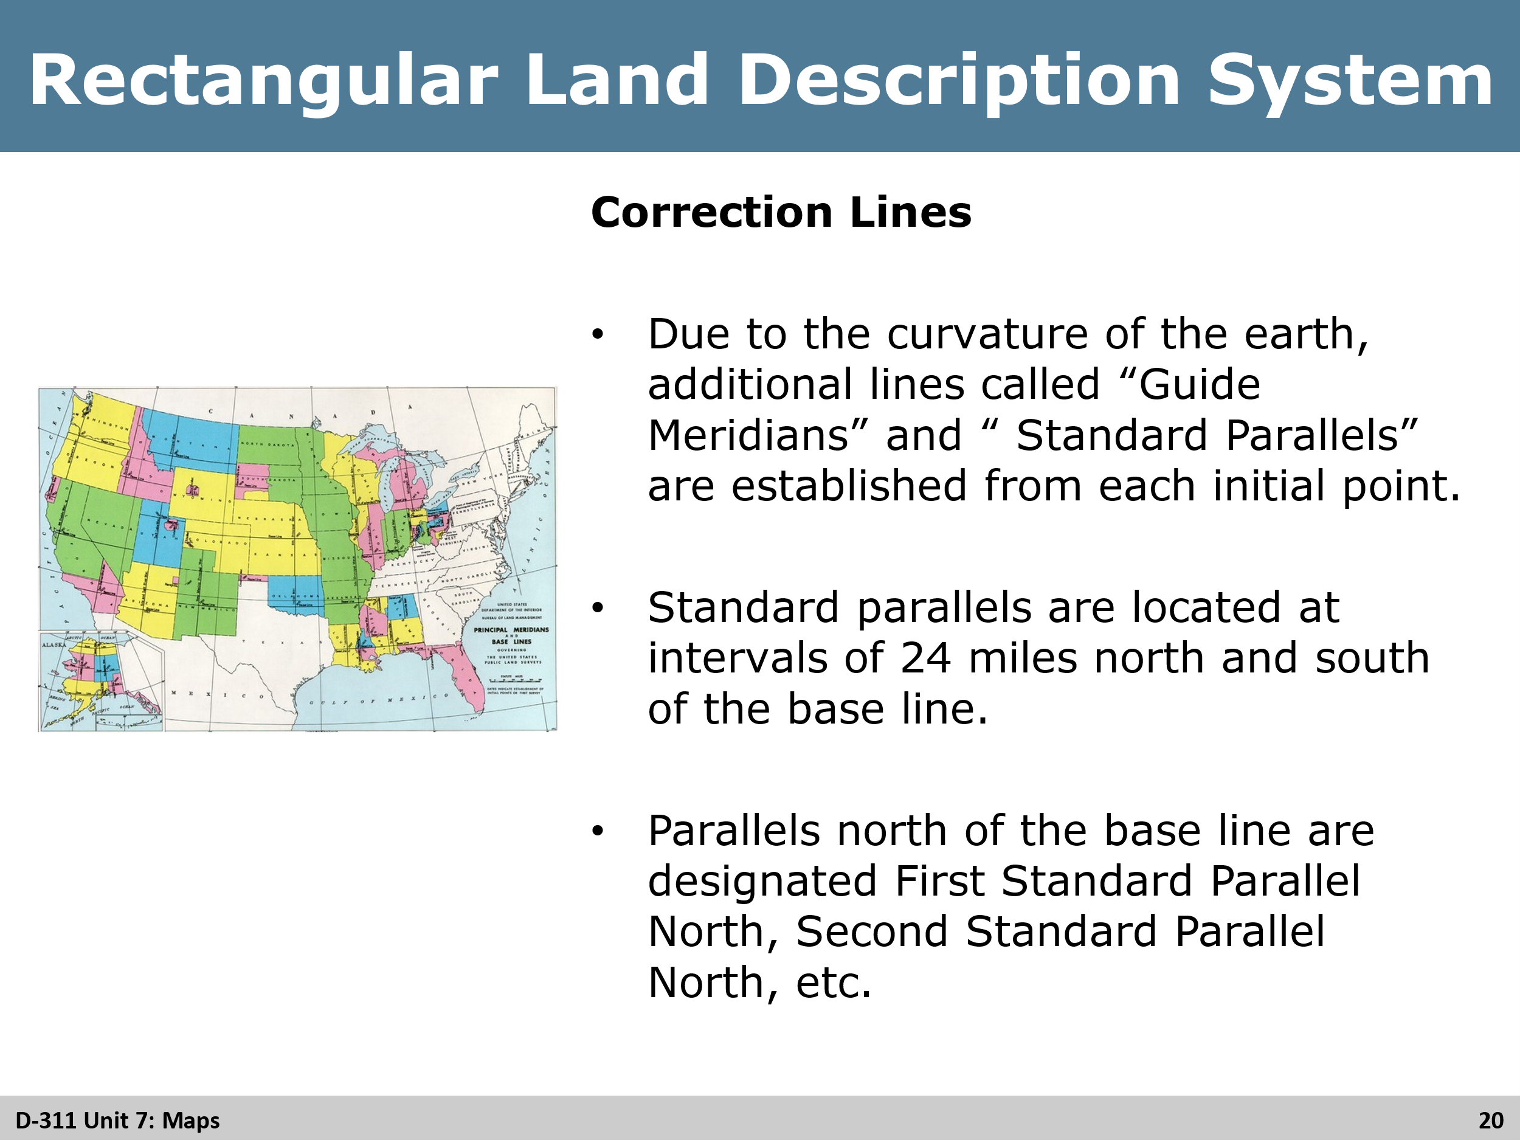
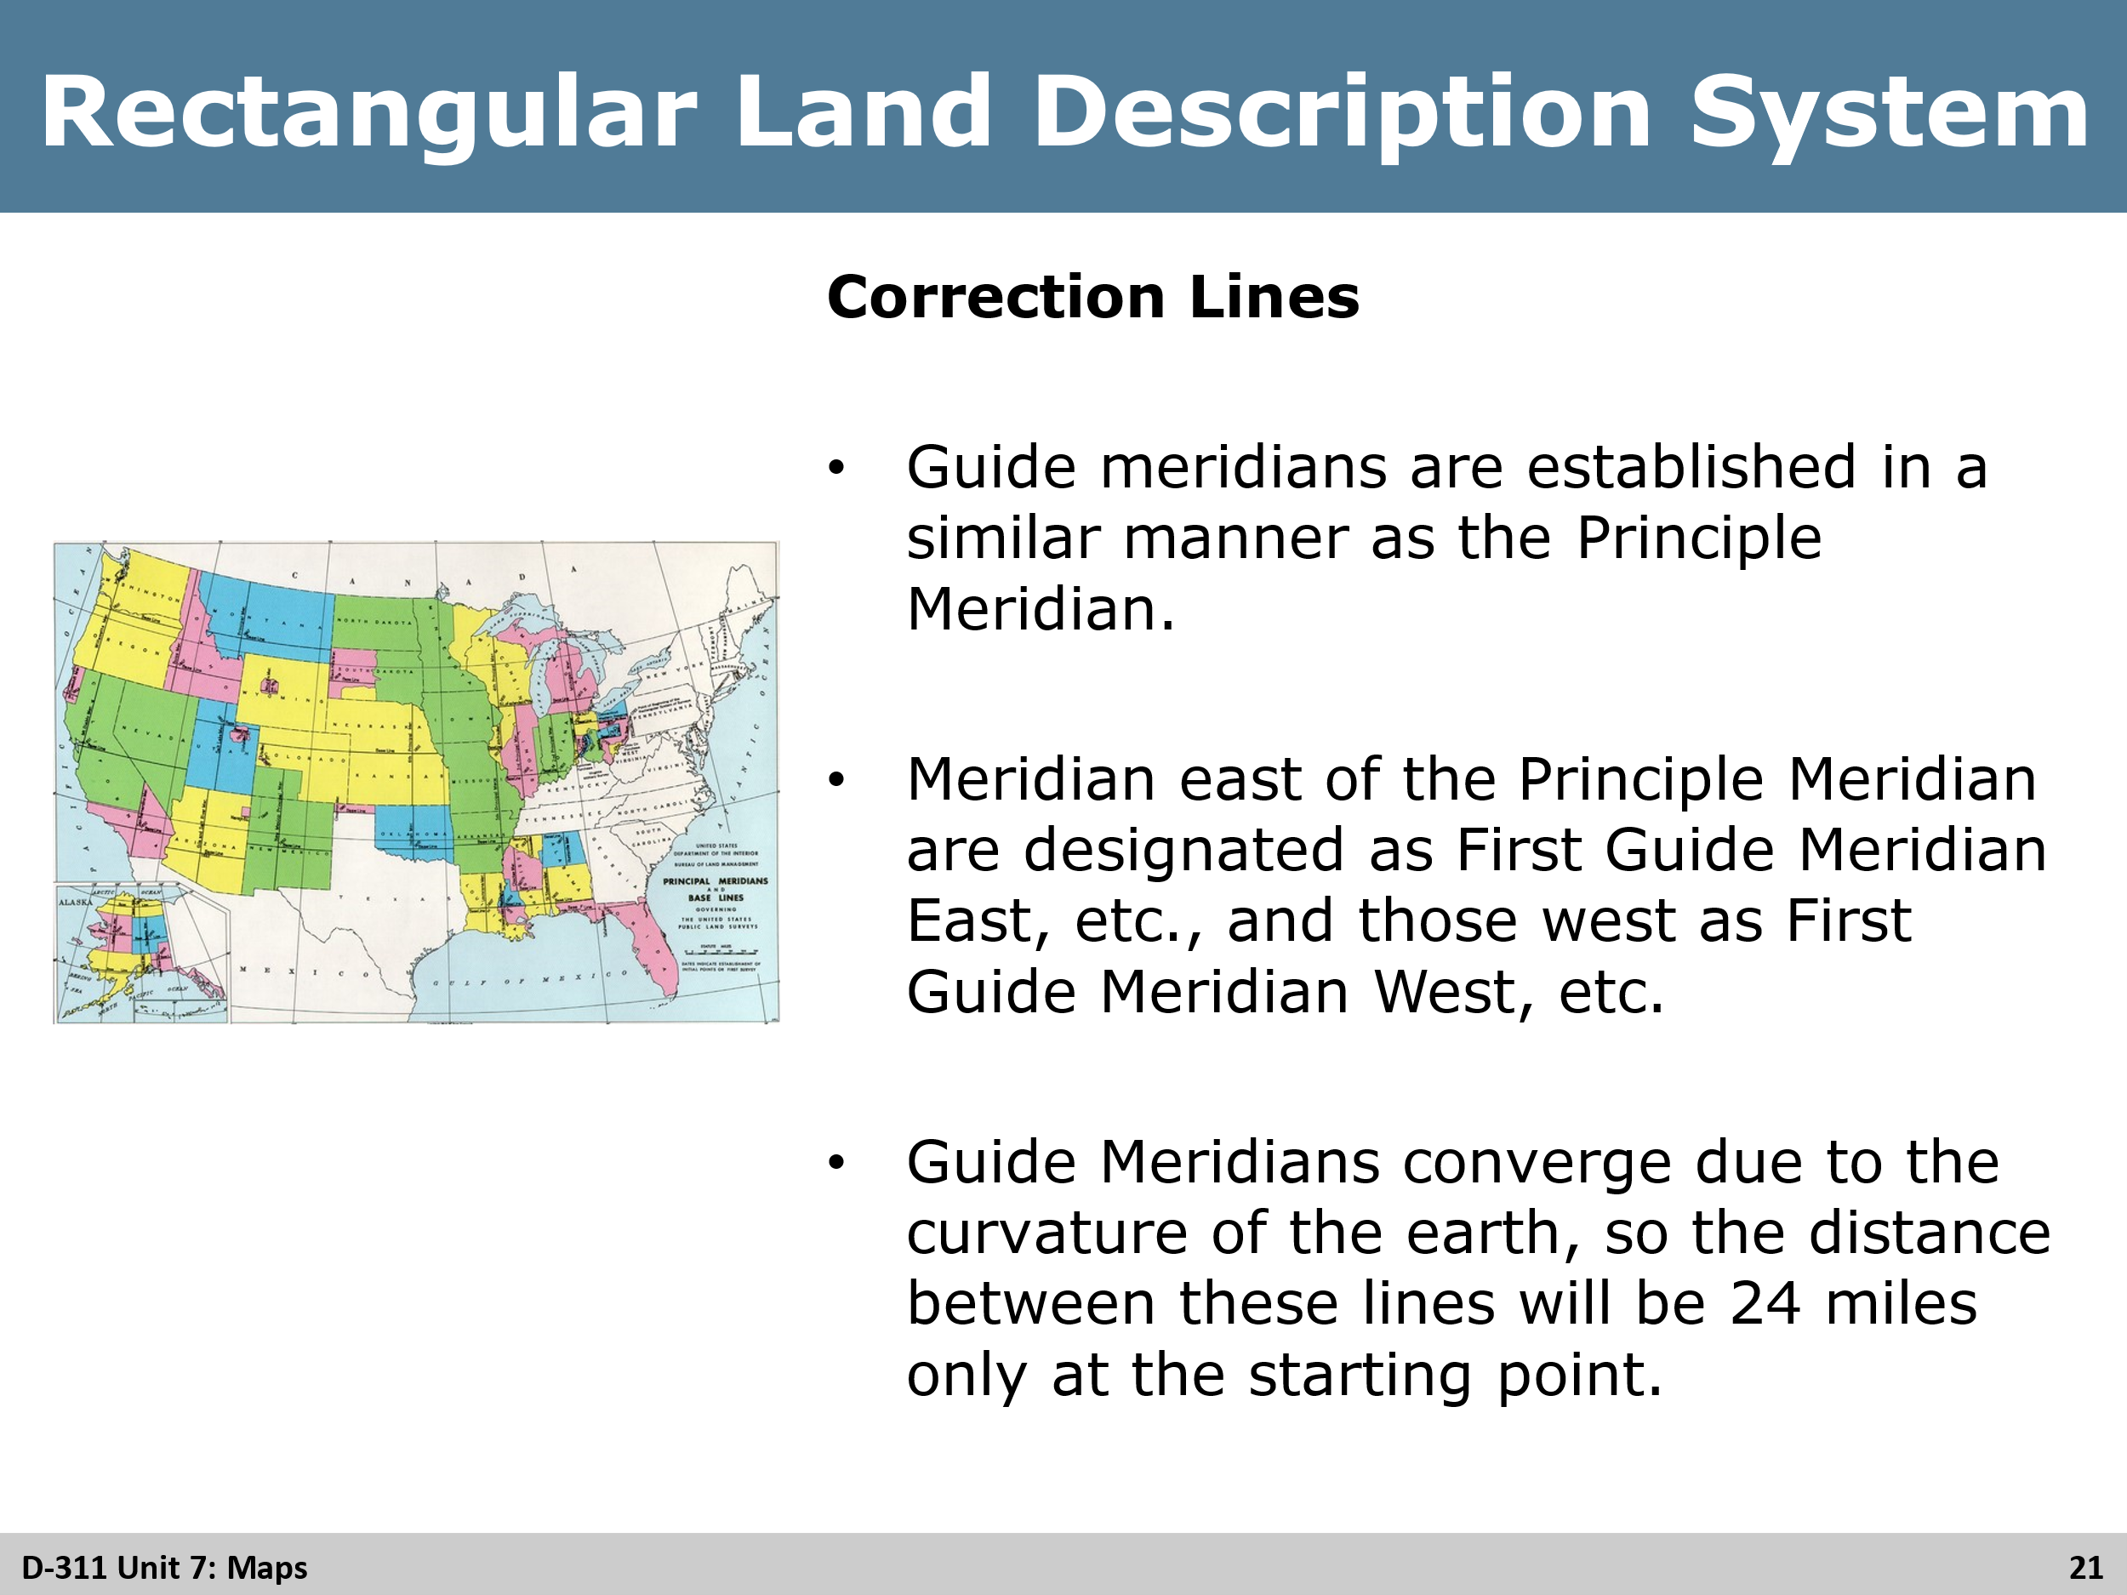
Review
Review all three slides with students, answering any questions that may come up from them as this can be a confusing section for some.

Slide 22 & 23
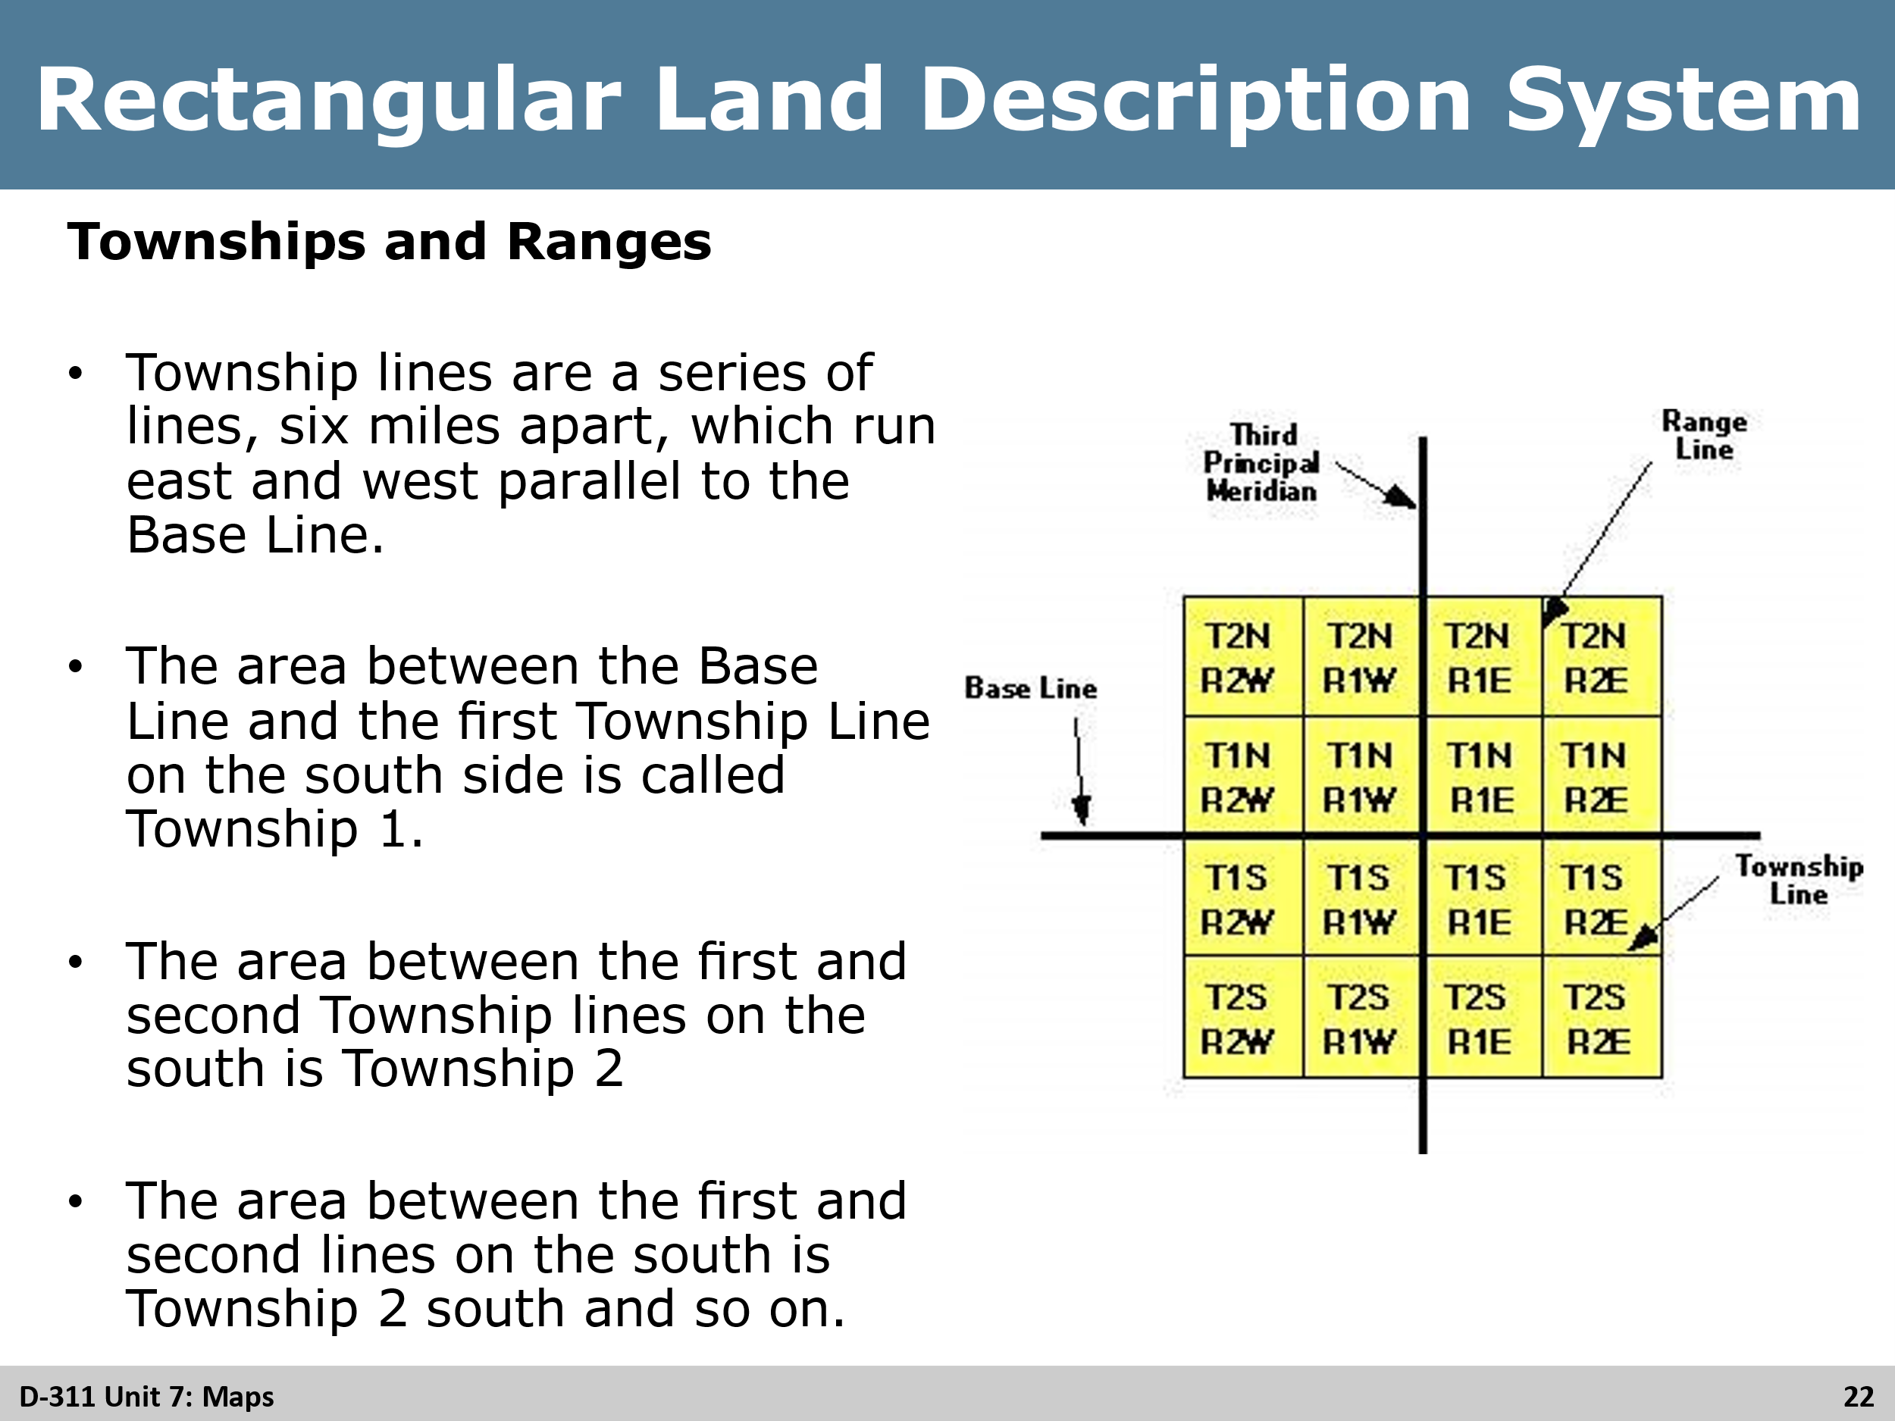
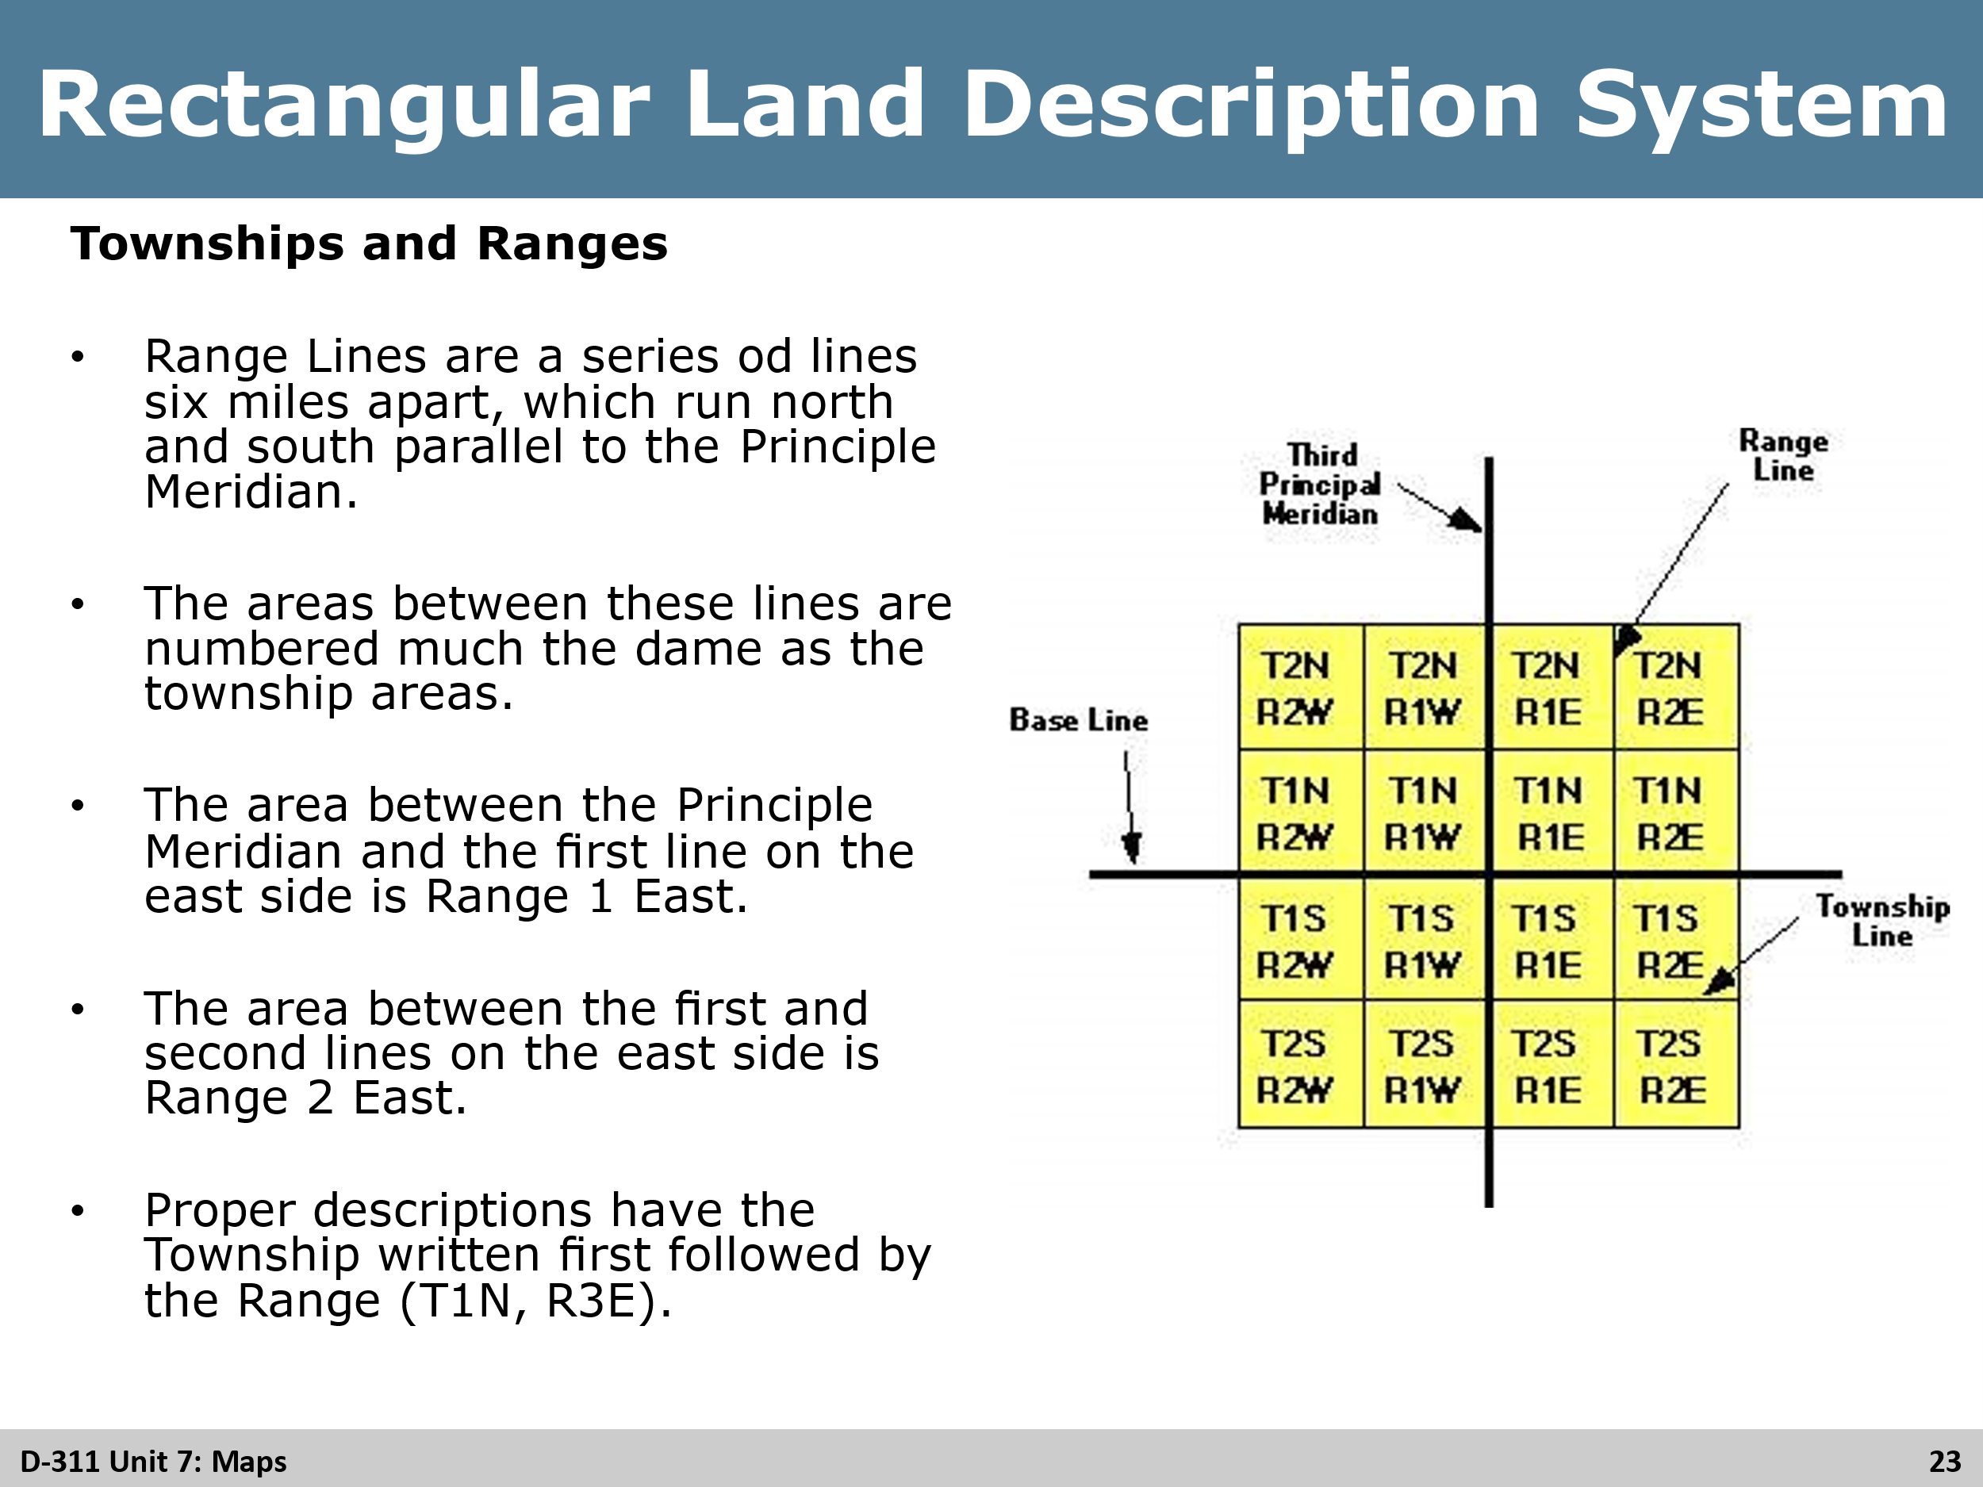
Review
Review all three slides with students, answering any questions that may come up from them as this can be a confusing section for some.

Slide 24 & 25
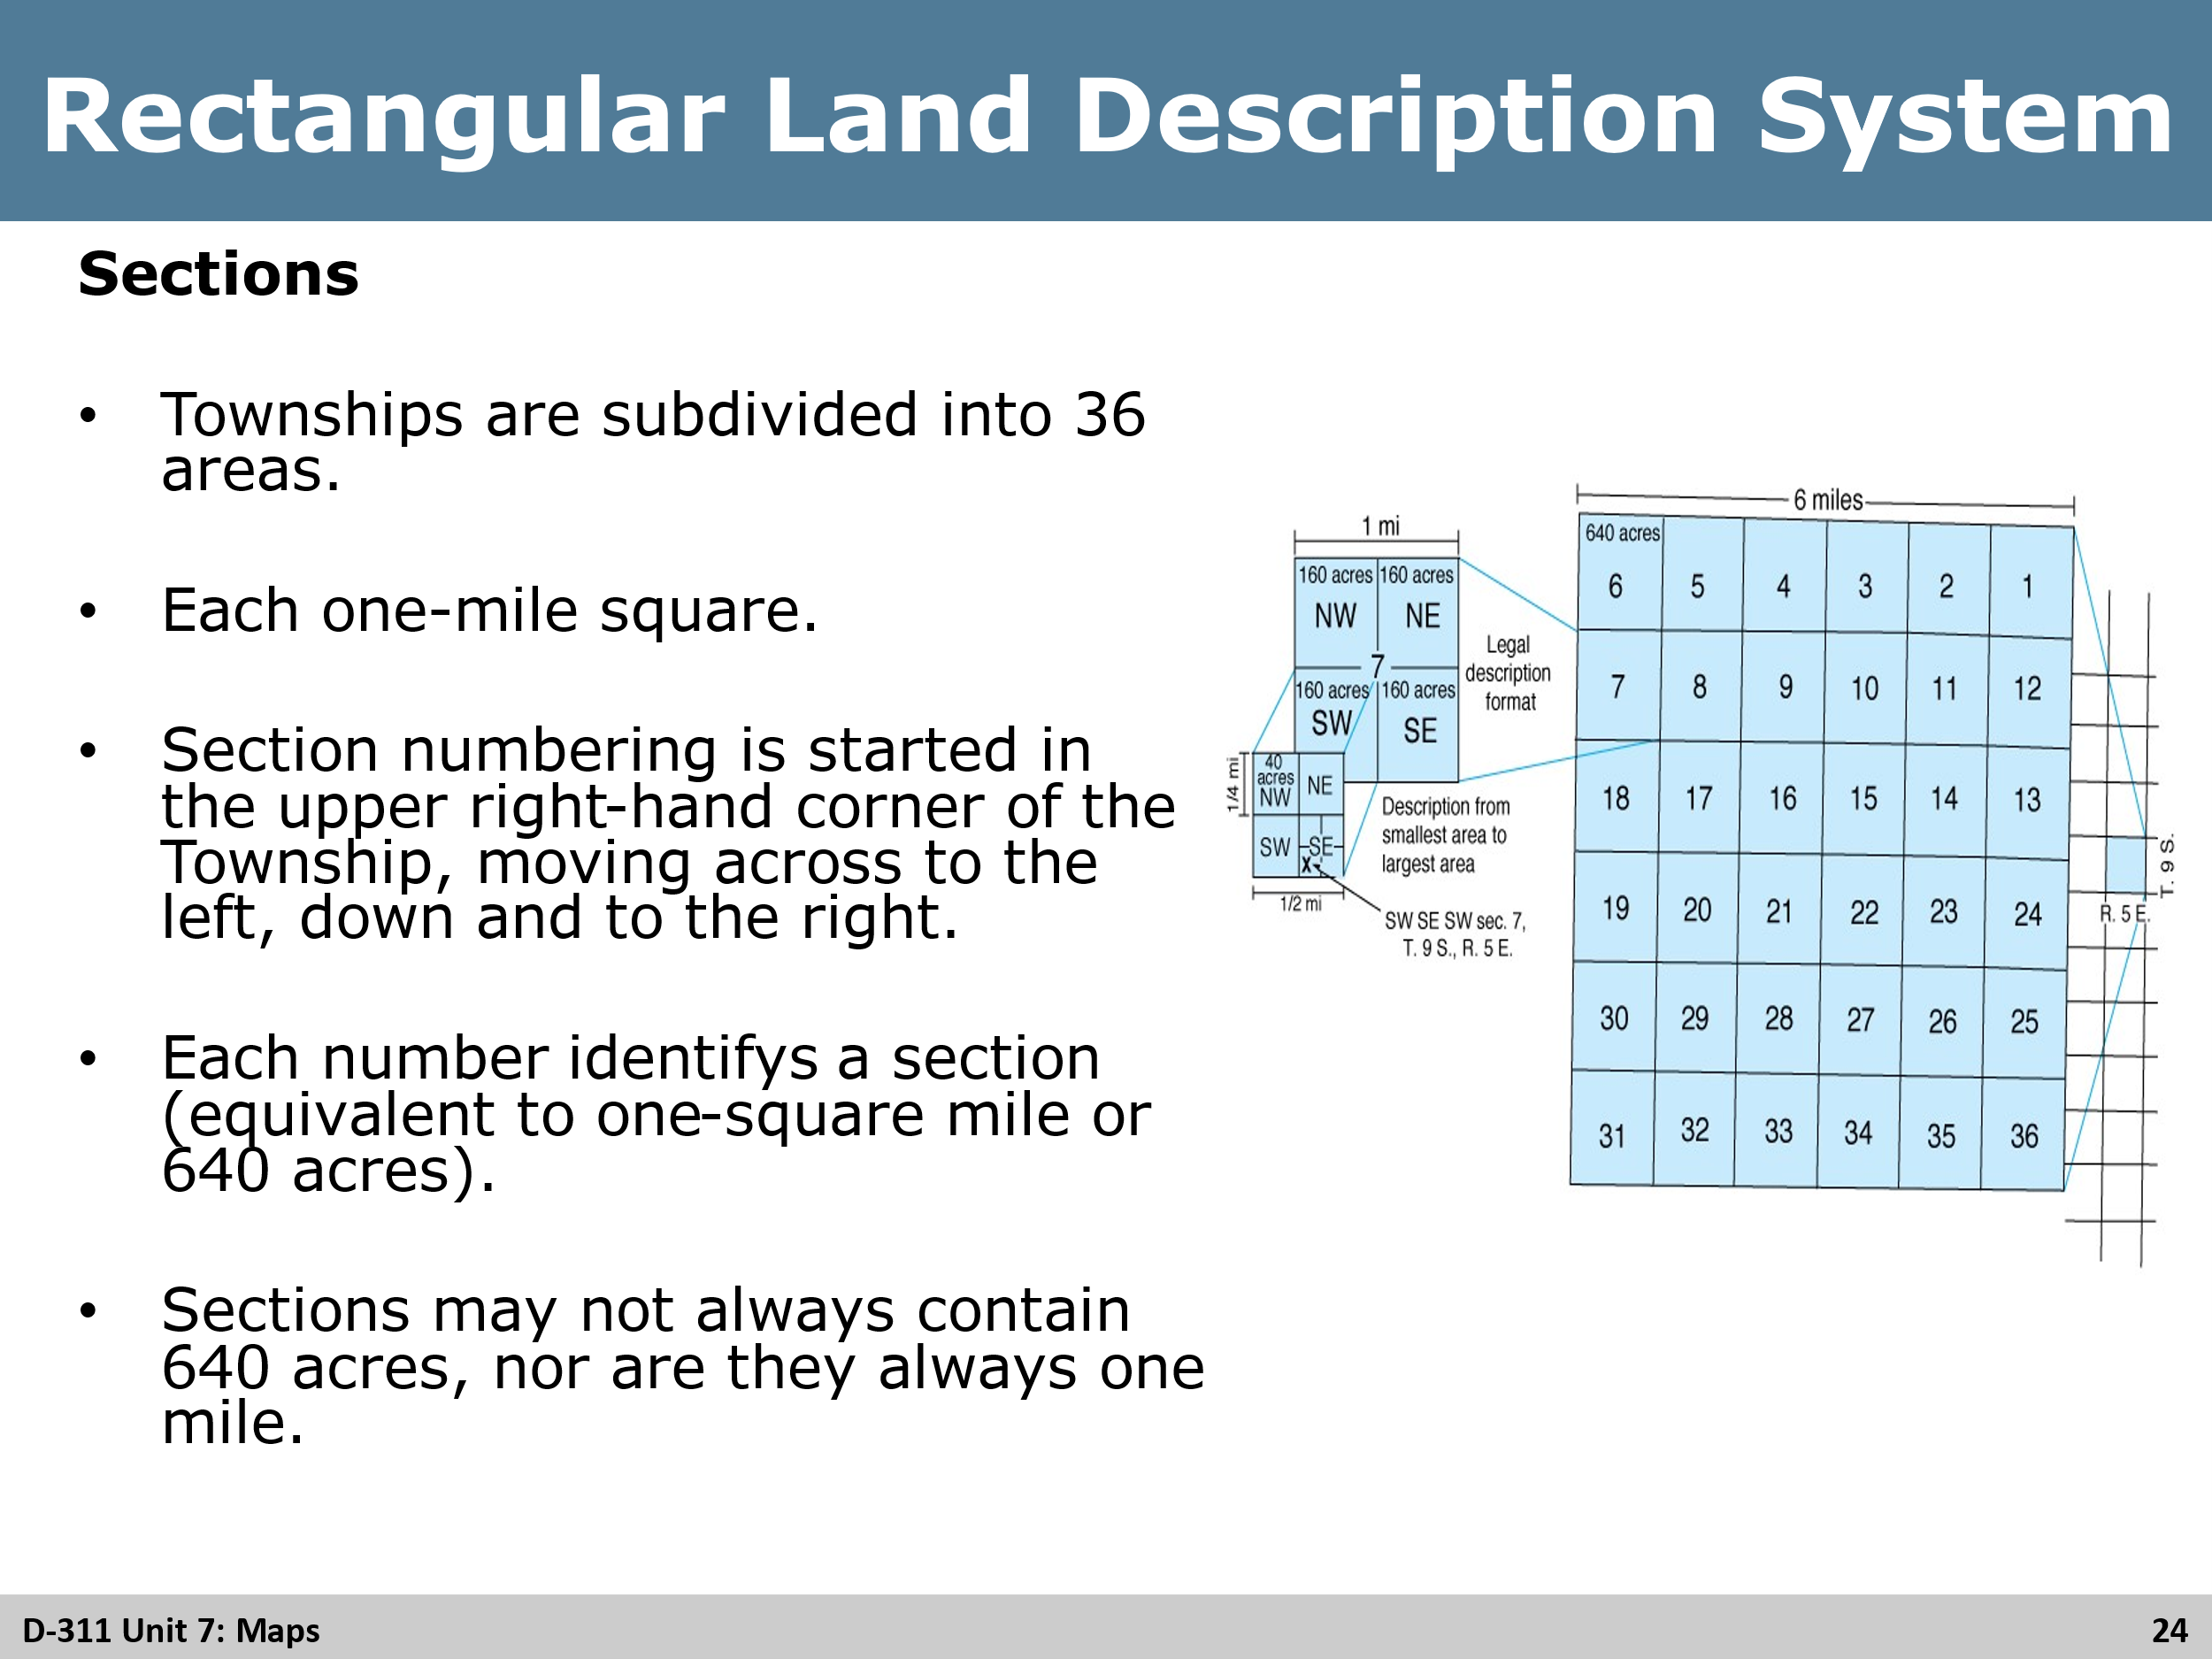
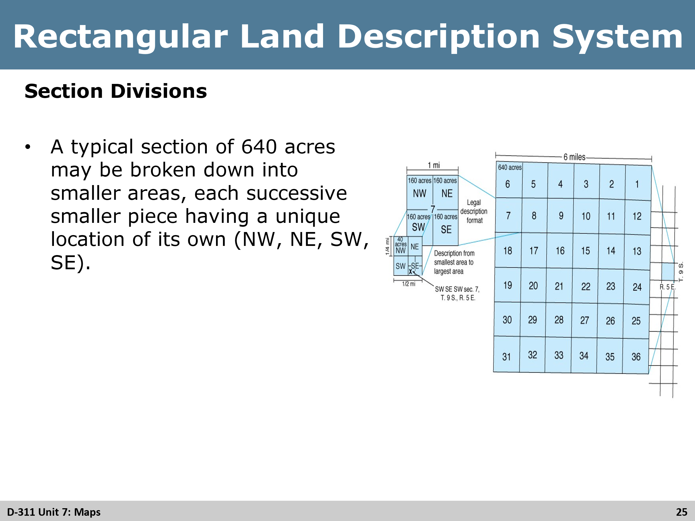
Review
Review all three slides with students, answering any questions that may come up from them as this can be a confusing section for some

Slide 26
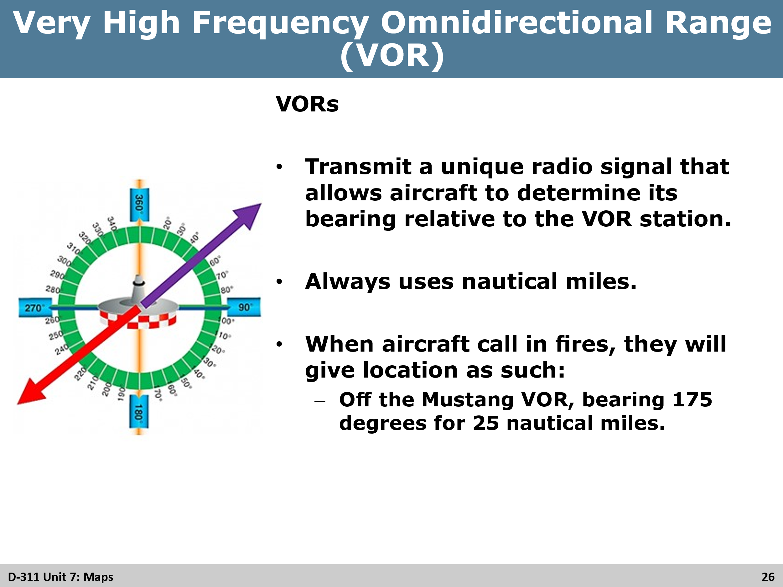
Review
Explain to the students, that typically aircraft will call in smoke reports and fire based of a bearing and distance from a VOR. This is especially true with commercial aircraft.
These reports can come over the radio or by phone calls from the centers GACC or directly from the FAA.
WildCAD or other CADs can typically covert these reports into lat/long and plot them on a map. The use of aeronautical charts will also assist IA dispatchers with plotting the location of the report so as to respond ground units to the incident.

Slide 27
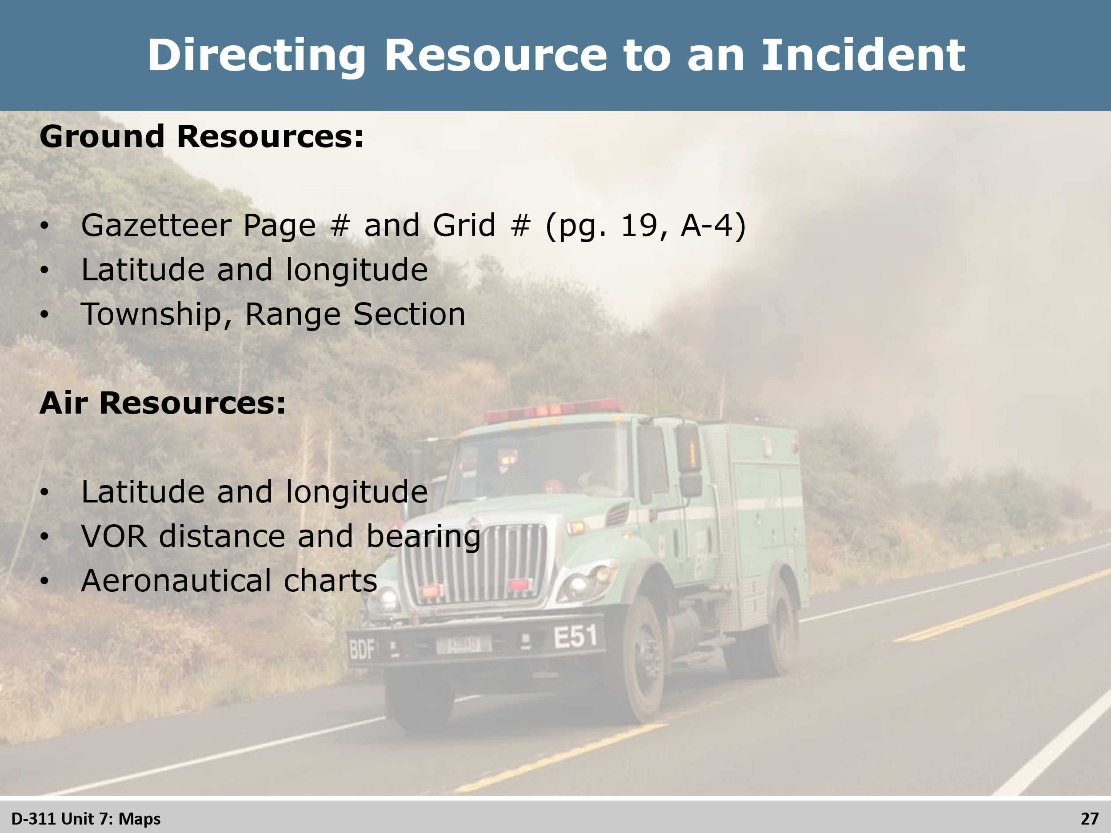
Group Discussion
Have a discussion with the students on ways to convey locations of incidents to the ground units.

Slide 28
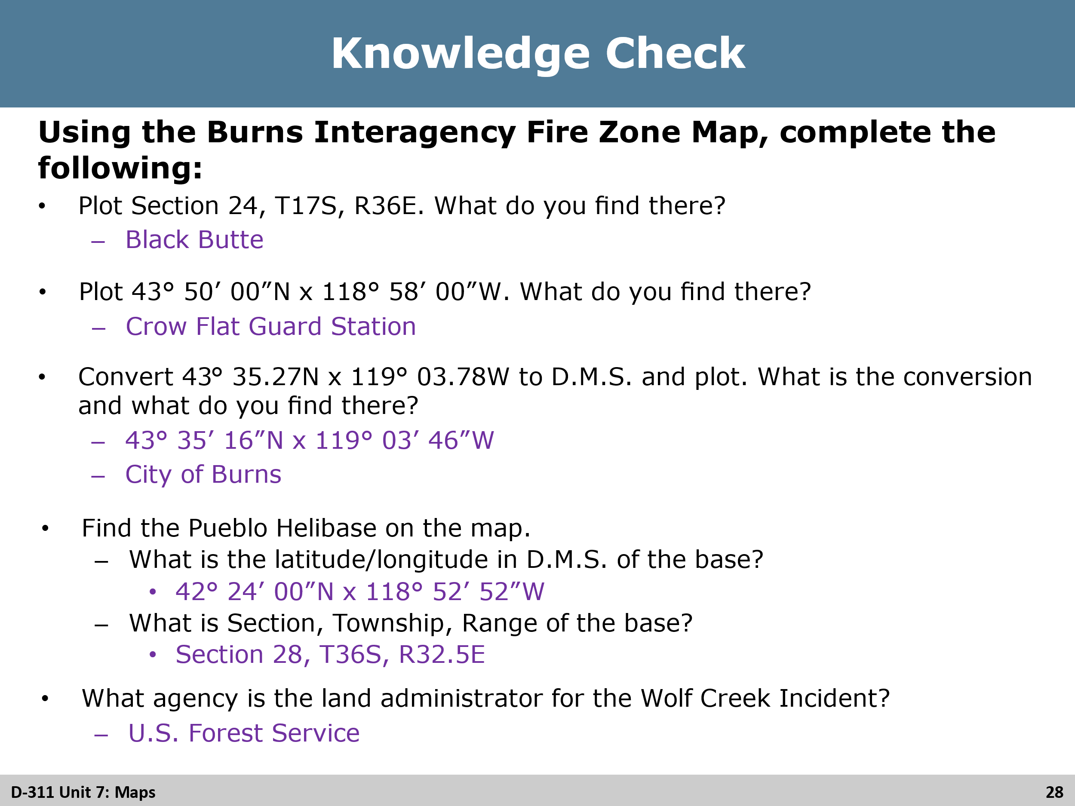
Activity
Final exercises for the students (30 min). Discuss the answers after and answer any questions from the students.

Slide 29
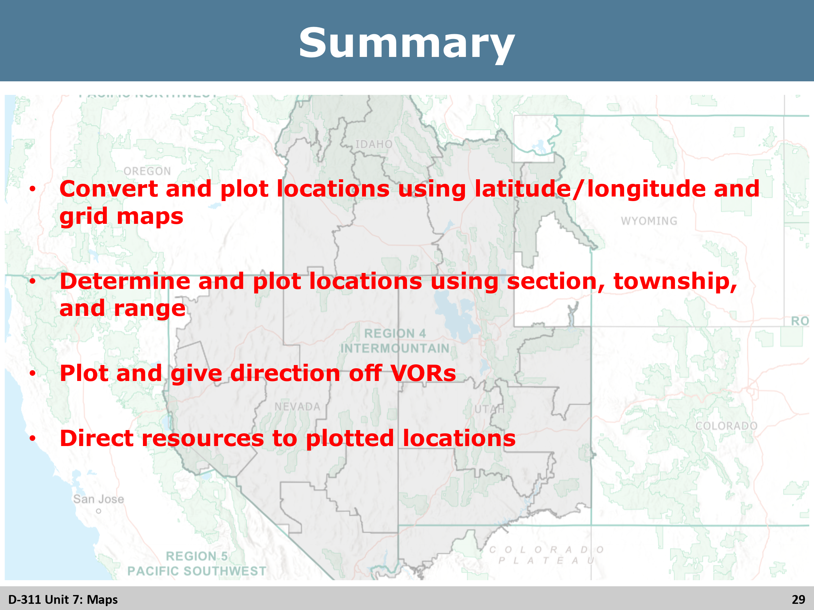
Review
Review the objectives again with the students ensuring that all objectives were met.

